By continuing to browse or by clicking “Accept All Cookies,” you agree to the storing of first- and third-party cookies on your device to enhance site navigation, analyse site usage, and assist in our marketing efforts. This means that social media platforms, as well as Google have access to your user data, which they may save together with other data they have collected from your use on different platforms. You can also [disable cookies here](https://tools.google.com/dlpage/gaoptout?hl=de).

[Cookie Policy](https://www.sustainablefashionmatterz.com/datenschutzerklrung-dsgvo-gdpr)

I accept cookies

* 
* 
* 

[**Sustainable Fashion Matterz**](https://www.sustainablefashionmatterz.com/)

* FIND PEOPLE
* ETHICAL BRANDS
* [BLOG](https://www.sustainablefashionmatterz.com/sustainable-fashion-blog)
* GOOD TO KNOW
* [ABOUT](https://www.sustainablefashionmatterz.com/about-sustainable-fashion-matterz)
* [CREATIVE MATTERZ FUND COMMUNITY AWARD](https://www.sustainablefashionmatterz.com/creative-matterz-fund-community-award)

[[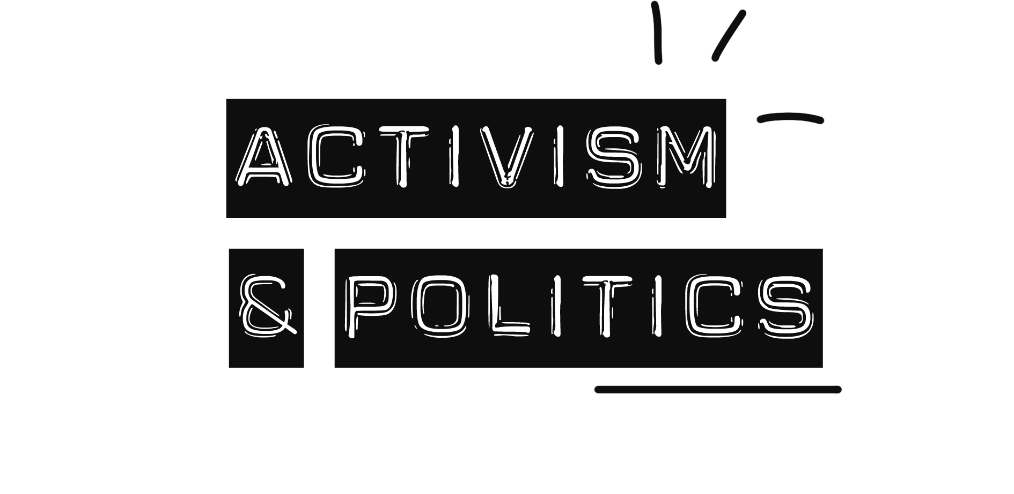](https://www.sustainablefashionmatterz.com/sustainable-fashion-blog/category/Activism%20&%20Politics)](https://www.sustainablefashionmatterz.com/sustainable-fashion-blog/category/Activism%20&%20Politics)

[[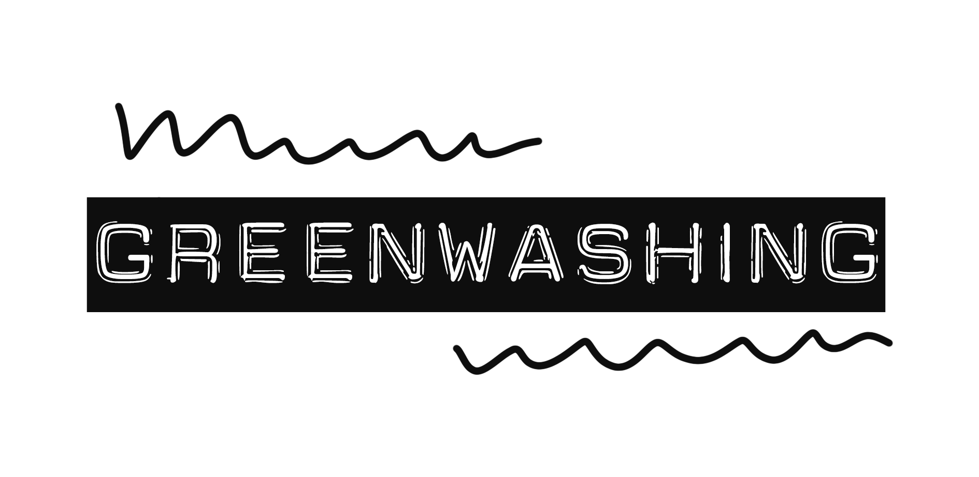](https://www.sustainablefashionmatterz.com/sustainable-fashion-blog/category/Greenwashing)](https://www.sustainablefashionmatterz.com/sustainable-fashion-blog/category/Greenwashing)

[[](https://www.sustainablefashionmatterz.com/sustainable-fashion-blog/category/Interviews)](https://www.sustainablefashionmatterz.com/sustainable-fashion-blog/category/Interviews)

[[](https://www.sustainablefashionmatterz.com/sustainable-fashion-blog/category/Brands)](https://www.sustainablefashionmatterz.com/sustainable-fashion-blog/category/Brands)

[[](https://www.sustainablefashionmatterz.com/sustainable-fashion-blog/category/Events)](https://www.sustainablefashionmatterz.com/sustainable-fashion-blog/category/Events)

[[](https://www.sustainablefashionmatterz.com/sustainable-fashion-blog/category/Materials)](https://www.sustainablefashionmatterz.com/sustainable-fashion-blog/category/Materials)



[Why I Don't Know if I Will Continue Sustainable Fashion Matterz](https://www.sustainablefashionmatterz.com/sustainable-fashion-blog/2022/5/11/why-i-dont-know-if-i-will-continue-sustainable-fashion-matterz)

May 4, 2023

by Cherie Birkner

IT’S TIME TO FACE REALITY AND **SPEAK A TRUTH I WISH WAS FALSE**.

It’s been some time now that I have been wondering where this blog is going. When I started this platform 7 years ago I had not seen anything of the sort. A platform which focuses on the solutions in sustainable fashion, a place showing the people paving the way towards a sustainable fashion industry and during this period this field blossomed. Those 7 years were full of hard work, value-driven partners, showcasing fair fashion and translating dry information into Instagrammable content.

However, as "sustainable fashion" and this platform have grown in the past years, so did my doubts, affecting the passion I once felt building this platform. Now it’s time to face reality and speak a truth I wish was false. **Currently, the fashion industry is at an all-time high on production rates, as well as the convenient yet often meaningless use of sustainability terminology.  I am disillusioned that the fashion industry will reach a healthy balance between use of resources, ethical production, providing for our actual needs as well as economic needs.** **The only way I see this happening is through** **drastic political measures**. This IS possible, however, personally, I have no interest in becoming a politician. Sustainable Fashion Matterz has always been based on the power of the individual. It remains the mix of consumer interest, the spread of information and activism that can lead to political change. Yes, every person does make a difference, but let’s face it: every cooperation and every government makes a bigger difference. You know 100 private organizations account for 71% of global GHG emissions, right? (Source: Carbon Majors Report, 2017)

**SUSTAINABLE FASHION**: *THESE WORDS HAVE LOST THEIR WEIGHT!*

“Sustainable fashion” has long been a moving target.  7 Years ago I would categorize Fairtrade, Organic T-Shirts as sustainable, today this alone does not make the cut. Today my view is more holistic; when I look at a brand claiming to be mission driven, putting sustainability first, but show marginal to no clear targets on reducing the overall amount of items/clothes they are producing. I smell greenwashing. According to the Clean Clothes Campaign we are producing about 100,000,000,000 clothes a year. From these about 70% are sold, of which on average only 20% are even worn regularly. With this calculation, we have a yearly surplus of 85 billion items of clothing! **WE DON’T NEED MORE NEW CLOTHES. WE NEED REUSE OF THE “OLD” ONES**. It no longer feels right to promote organic and fair-trade items from raw materials which are industrially produced. Further innovations we once saw as solutions have turned out to be rather the opposite. Recycled PET, for example, often uses far more energy in production and also has a higher chance of releasing toxins into the ecosystem and into our skin than virgin polyester.  While I appreciate and respect the hard work of brands that genuinely try to do good, as long as brands do not incorporate holistic solutions, it no longer feels right to promote items that were made using up precious natural resources. Why not get real creative with the things we have?  It’s not buying new. It’s using what is already there. It’s redesigning. It’s upcycling. It’s sharing. It's really, really good aesthetic and smart design. It’s what you will want for a long time. It’s about producing and buying less. LESS NEW = LESS CO2.

I want to see more of those special, unique, one-of-a-kind pieces. The ones that are so precious, you repair them and pass them on to your friends and family. The kind of pieces you would be happy to inherit.

THE WORLD’S ON FIRE. **DON’T LET IT BURN YOU OUT.**

When the air pressure drops, you need to put your own mask on first, *then* you can help others. When Sustainable Fashon Matterz was at +/- 10k unique views/month I decided it was time to not only realize our own projects here, but to pass on the possibilities we had created over the years. This became the [Creative Matterz Fund](https://www.sustainablefashionmatterz.com/creative-matterz-fund-community-award) where we supported 10 international projects looking at fashion and sustainability. The results were an impressive, ranging from a [gigantic mural made of fashion waste displayed in the streets of Uganda](https://www.sustainablefashionmatterz.com/sustainable-fashion-blog/xcess-street-art-creative-matterz-fund), an [open air performance art installation](https://www.sustainablefashionmatterz.com/sustainable-fashion-blog/en-plein-air-interactive-clothing-installation-creative-matterz-fund), a [sustainability guide for beginners](https://www.sustainablefashionmatterz.com/sustainable-fashion-blog/the-stitch-sustainability-beginners-guide-creative-matterz-fund) to a [documentary film portraying different cultural views on sustainable fashion consumption](https://www.sustainablefashionmatterz.com/sustainable-fashion-blog/feel-the-ground-short-documentary-fiction-film-creative-matterz-fund). Behind the scenes, however, our team of volunteers struggled with the balance of realizing this project and work that pays the bills. I caught myself having invested all of my time into this project and not earning a cent for two months, which was quite alarming and made clear to me that this is by no means a sustainable approach to making a difference. Ever since Creative Matterz Fund Round N°1 has been completed, I have had somewhat of a burn-out for the topic and this platform. Alone, this article has been in the making since February 2022. It has been extremely hard to bring up energy to create content here, and **it is now** **clear to me how important it is to take care of yourself first, because only this way you can really support others sustainably**.

WHERE DO WE GO FROM HERE?

The title of this post reads “Why I don’t know if I will continue Sustainable Fashion Matterz”, however it could also read “Why **I don’t know *how* I will continue Sustainable Fashion Matterz**'' because here and there I feel inspiration returning, although it has a different flavor now. It is time to let go of some ideas of the past, and reevaluate my own views on fashion today.

Having said all this, ***(sustainable)*** ***fashion will always matter***. I have yet to find the way to move forward, but I would love to hear your thoughts (for example [via e-mail](mailto:cheriebirkner@sustainablefashionmatterz.com?subject=Reply%20to%20Article.%20Sustainable%20Fashion%20Today&)) as I share mine with you. **Sometimes to move forward, you have to pause.**

In the meantime, there is something we can do now to get a step closer to those (hopefully drastic) political measures we need: if you are an EU citizen, I would like to invite you to ***sign the Good Clothes Fair Pay petition***. 1 Million signatures are needed for [proposed legislation](https://www.goodclothesfairpay.eu/s/NEW-Briefing-Doc-ECI-Proposal-v4.pdf) which requires all brands and retailers selling products in the EU to conduct due diligence on living wages across their global supply chains.

[**SIGH HERE**](https://www.goodclothesfairpay.eu/)

[[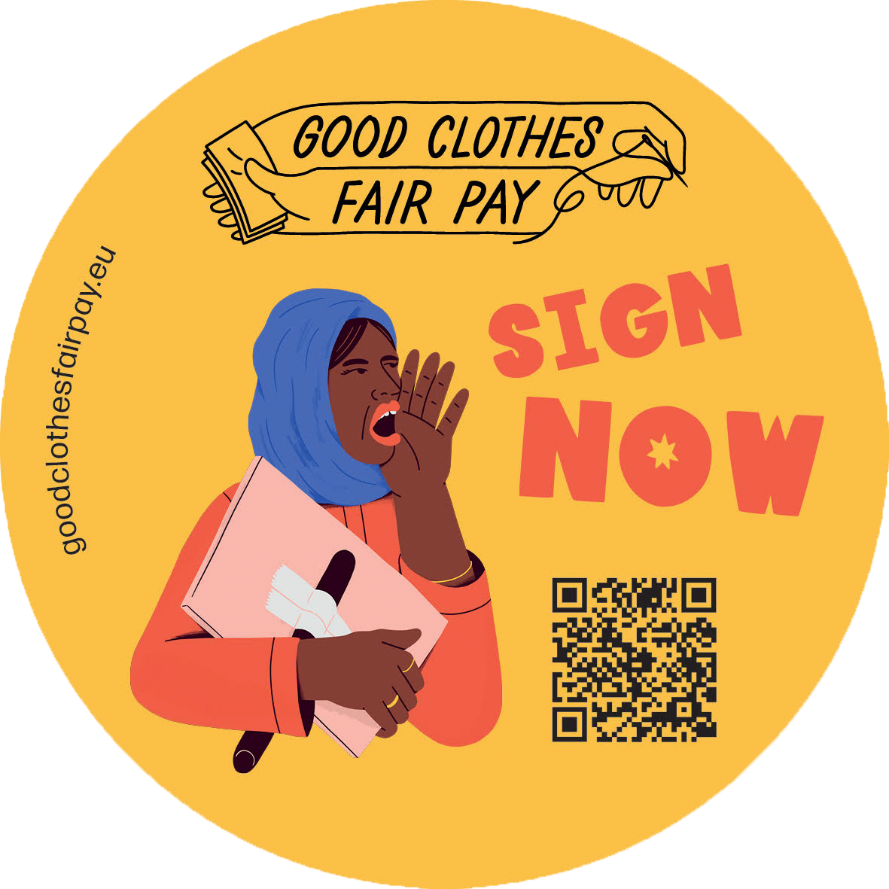](https://www.goodclothesfairpay.eu/)](https://www.goodclothesfairpay.eu/" \t "_blank)



© Marco Lombardi

In [Activism & Politics](https://www.sustainablefashionmatterz.com/sustainable-fashion-blog/category/Activism+%26+Politics)Tags [Good Clothes Fair Pay](https://www.sustainablefashionmatterz.com/sustainable-fashion-blog/tag/Good+Clothes+Fair+Pay), [Cherie Birkner](https://www.sustainablefashionmatterz.com/sustainable-fashion-blog/tag/Cherie+Birkner), [Personal Stories](https://www.sustainablefashionmatterz.com/sustainable-fashion-blog/tag/Personal+Stories), [Sustainability Claims](https://www.sustainablefashionmatterz.com/sustainable-fashion-blog/tag/Sustainability+Claims)

1 Likes[Comment](https://www.sustainablefashionmatterz.com/sustainable-fashion-blog/2022/5/11/why-i-dont-know-if-i-will-continue-sustainable-fashion-matterz#comments-627bba5bf4978468f9f36197)

Share



All photos ©️Cherie Birkner

[Ukrainian Upcycling Designers in Berlin](https://www.sustainablefashionmatterz.com/sustainable-fashion-blog/2022/5/3/ukrainian-upcycling-designers-in-berlin)

May 4, 2022

One of a Kind Upcycling Fashion Designs by Ukrainian Refugees in Berlin. Produced in Haus der Materialisierung.

[Read More](https://www.sustainablefashionmatterz.com/sustainable-fashion-blog/2022/5/3/ukrainian-upcycling-designers-in-berlin)

In [Brands](https://www.sustainablefashionmatterz.com/sustainable-fashion-blog/category/Brands)Tags [Editorial](https://www.sustainablefashionmatterz.com/sustainable-fashion-blog/tag/Editorial), [Limited Edition](https://www.sustainablefashionmatterz.com/sustainable-fashion-blog/tag/Limited+Edition), [Upcycling](https://www.sustainablefashionmatterz.com/sustainable-fashion-blog/tag/Upcycling), [Berlin](https://www.sustainablefashionmatterz.com/sustainable-fashion-blog/tag/Berlin), [Haus der Materialisierung](https://www.sustainablefashionmatterz.com/sustainable-fashion-blog/tag/Haus+der+Materialisierung), [Ukrainian Fashion](https://www.sustainablefashionmatterz.com/sustainable-fashion-blog/tag/Ukrainian+Fashion), [Knitted](https://www.sustainablefashionmatterz.com/sustainable-fashion-blog/tag/Knitted)

1 Likes[1 Comment](https://www.sustainablefashionmatterz.com/sustainable-fashion-blog/2022/5/3/ukrainian-upcycling-designers-in-berlin#comments-627148a40c291a6f4c48ad89)

Share

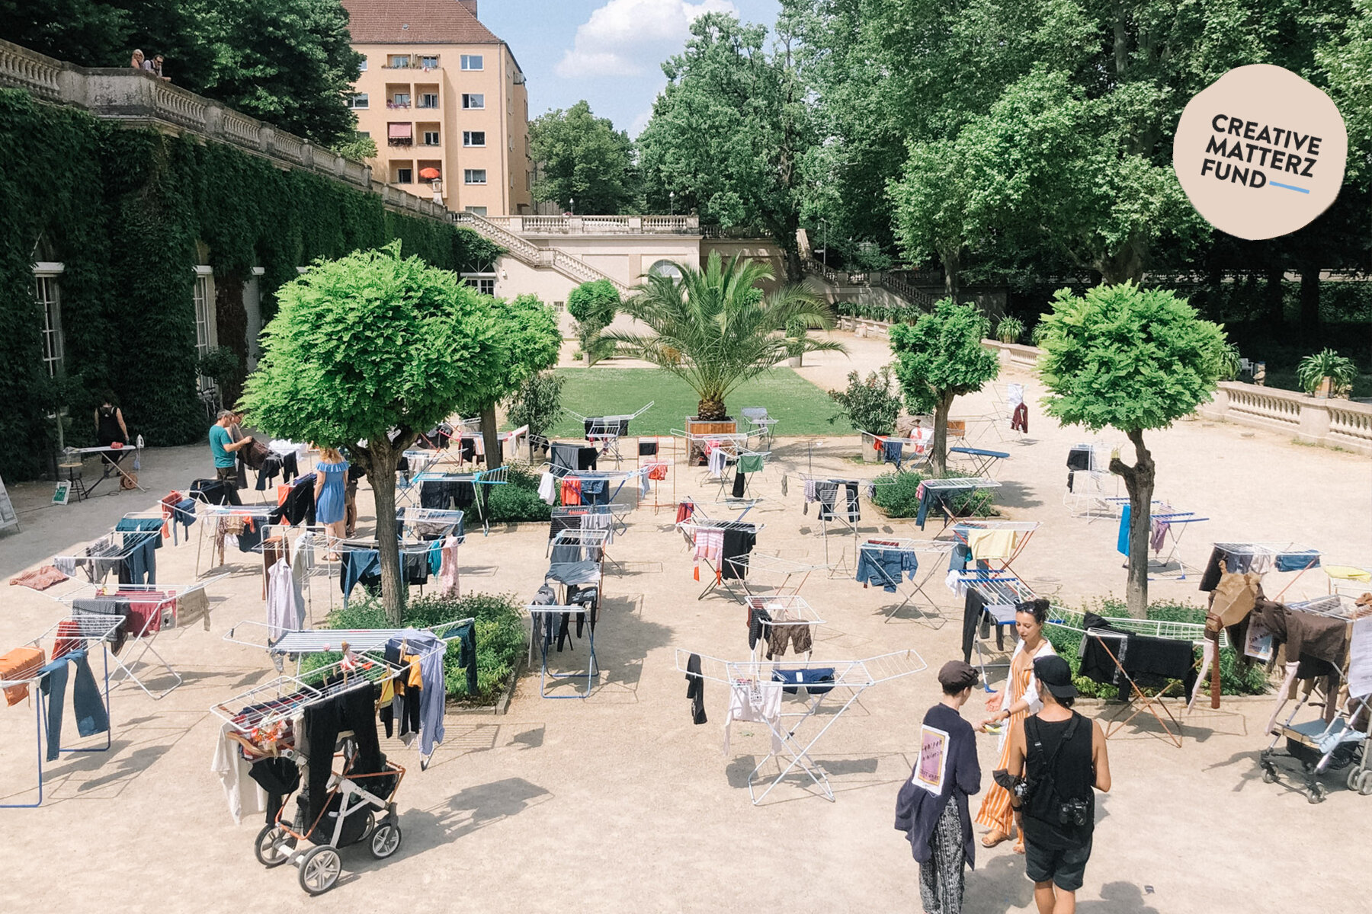

©Cherie Birkner

[EN PLEIN AIR Interactive Clothing Installation | Creative Matterz Fund](https://www.sustainablefashionmatterz.com/sustainable-fashion-blog/en-plein-air-interactive-clothing-installation-creative-matterz-fund)

August 2, 2021

During the ‘48 Stunden Neukölln’ art festival in Berlin we invited residents and visitors to our participatory art installation ‘En Plein Air’ and to STREET-SHOPPPING tours on mobile clothes horses.

[Read More](https://www.sustainablefashionmatterz.com/sustainable-fashion-blog/en-plein-air-interactive-clothing-installation-creative-matterz-fund)

In [Activism & Politics](https://www.sustainablefashionmatterz.com/sustainable-fashion-blog/category/Activism+%26+Politics)Tags [Creative Matterz Fund](https://www.sustainablefashionmatterz.com/sustainable-fashion-blog/tag/Creative+Matterz+Fund), [Creative Matterz Fund Round N°1](https://www.sustainablefashionmatterz.com/sustainable-fashion-blog/tag/Creative+Matterz+Fund+Round+N%C2%B01)

0 Likes[3 Comments](https://www.sustainablefashionmatterz.com/sustainable-fashion-blog/en-plein-air-interactive-clothing-installation-creative-matterz-fund#comments-60d1afcd73494d58b5fdcdc0)

Share

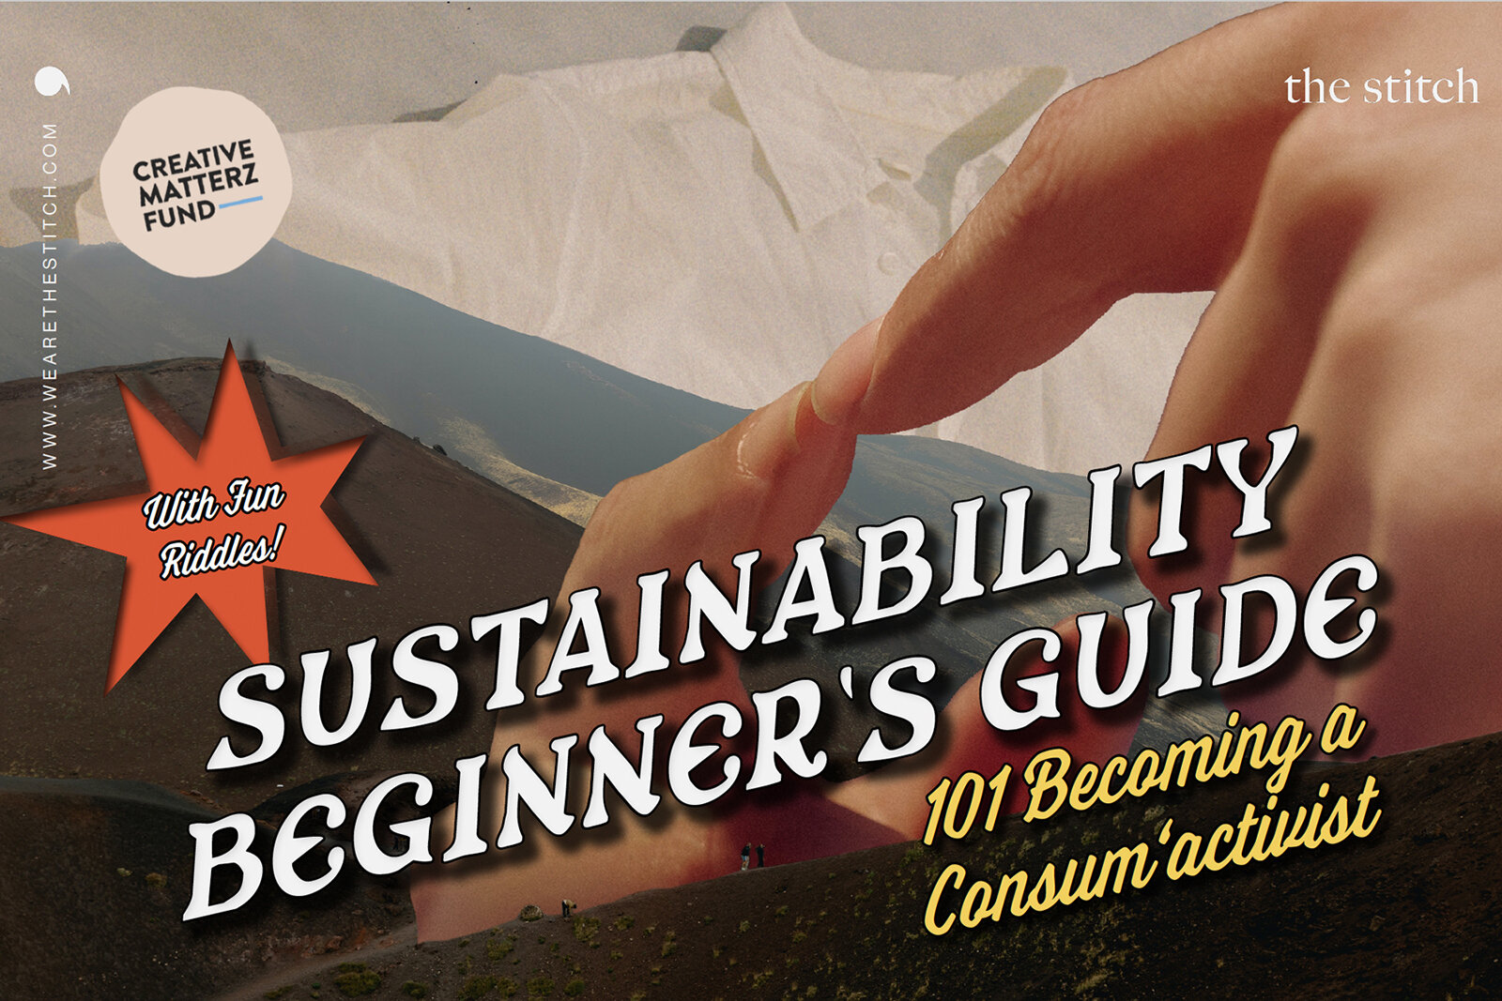

[THE STITCH Sustainability Beginner's Guide | Creative Matterz Fund](https://www.sustainablefashionmatterz.com/sustainable-fashion-blog/the-stitch-sustainability-beginners-guide-creative-matterz-fund)

August 2, 2021

“We share change-making fashion brands and educate about responsible consumption. Our mission is to transform the fashion industry towards a circular and socially responsible system and drive businesses to serve the UN's SDGs. Regardless of your starting point in humanitarian justice and environmentalism, everyone is inclusively invited to be part of this movement.” - [The Stitch](https://wearethestitch.com/home)

[Read More](https://www.sustainablefashionmatterz.com/sustainable-fashion-blog/the-stitch-sustainability-beginners-guide-creative-matterz-fund)

In [Activism & Politics](https://www.sustainablefashionmatterz.com/sustainable-fashion-blog/category/Activism+%26+Politics)Tags [Creative Matterz Fund](https://www.sustainablefashionmatterz.com/sustainable-fashion-blog/tag/Creative+Matterz+Fund), [Creative Matterz Fund Round N°1](https://www.sustainablefashionmatterz.com/sustainable-fashion-blog/tag/Creative+Matterz+Fund+Round+N%C2%B01)

0 Likes[Comment](https://www.sustainablefashionmatterz.com/sustainable-fashion-blog/the-stitch-sustainability-beginners-guide-creative-matterz-fund#comments-60d45be435ae8a59fb6b9104)

Share

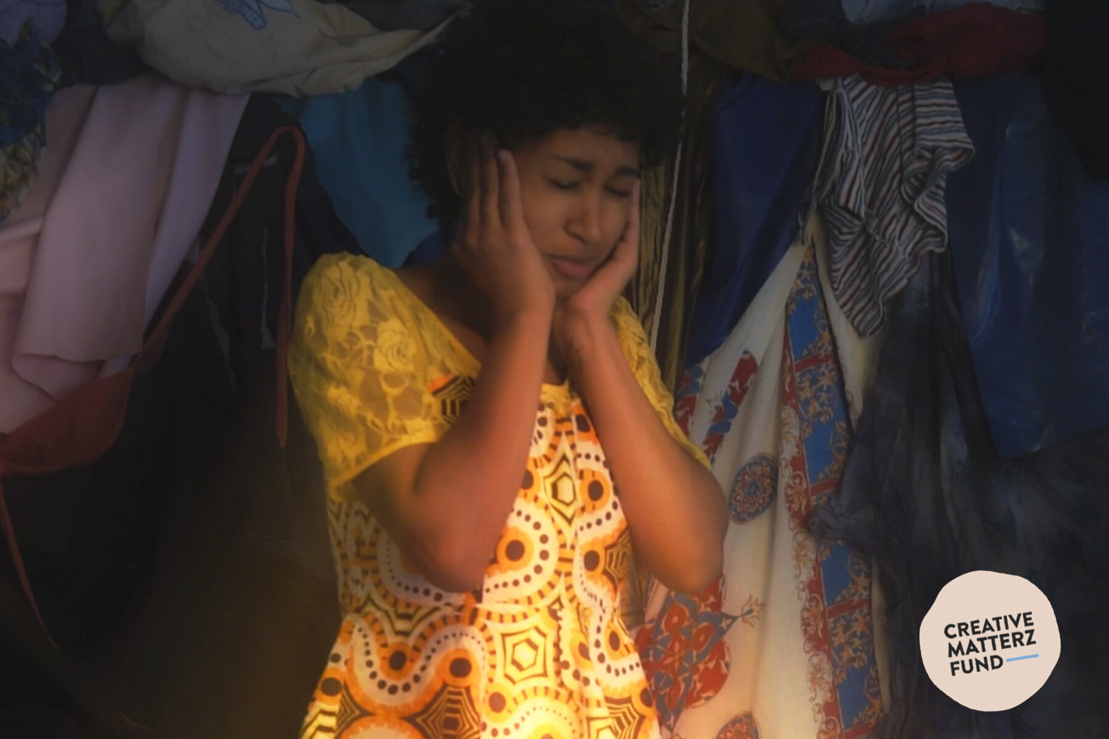

[FEEL THE GROUND Short Documentary-Fiction Film | Creative Matterz Fund](https://www.sustainablefashionmatterz.com/sustainable-fashion-blog/feel-the-ground-short-documentary-fiction-film-creative-matterz-fund)

August 2, 2021

Feel The Ground is a short docu-fiction film in the first person. It is in Wolof, English and German. It portrays different cultural views on sustainable fashion consumption and the social issues around it. It tells the journey of a Senegalese woman living in Berlin where she studies Film. While working on one of her university assignments, she decides to create a documentary on Sustainable Fashion which led to her dreaming about the times she used to be bullied for wearing second-hand clothing. Through her voyage, she's giving her thoughts on the matter and interviewing people to find new perspectives. Towards the end, she confronts the bully.

[Read More](https://www.sustainablefashionmatterz.com/sustainable-fashion-blog/feel-the-ground-short-documentary-fiction-film-creative-matterz-fund)

In [Activism & Politics](https://www.sustainablefashionmatterz.com/sustainable-fashion-blog/category/Activism+%26+Politics), [Interviews](https://www.sustainablefashionmatterz.com/sustainable-fashion-blog/category/Interviews)Tags [Creative Matterz Fund](https://www.sustainablefashionmatterz.com/sustainable-fashion-blog/tag/Creative+Matterz+Fund), [Creative Matterz Fund Round N°1](https://www.sustainablefashionmatterz.com/sustainable-fashion-blog/tag/Creative+Matterz+Fund+Round+N%C2%B01)

0 Likes[Comment](https://www.sustainablefashionmatterz.com/sustainable-fashion-blog/feel-the-ground-short-documentary-fiction-film-creative-matterz-fund#comments-60d45ce41b2124212bb9433f)

Share

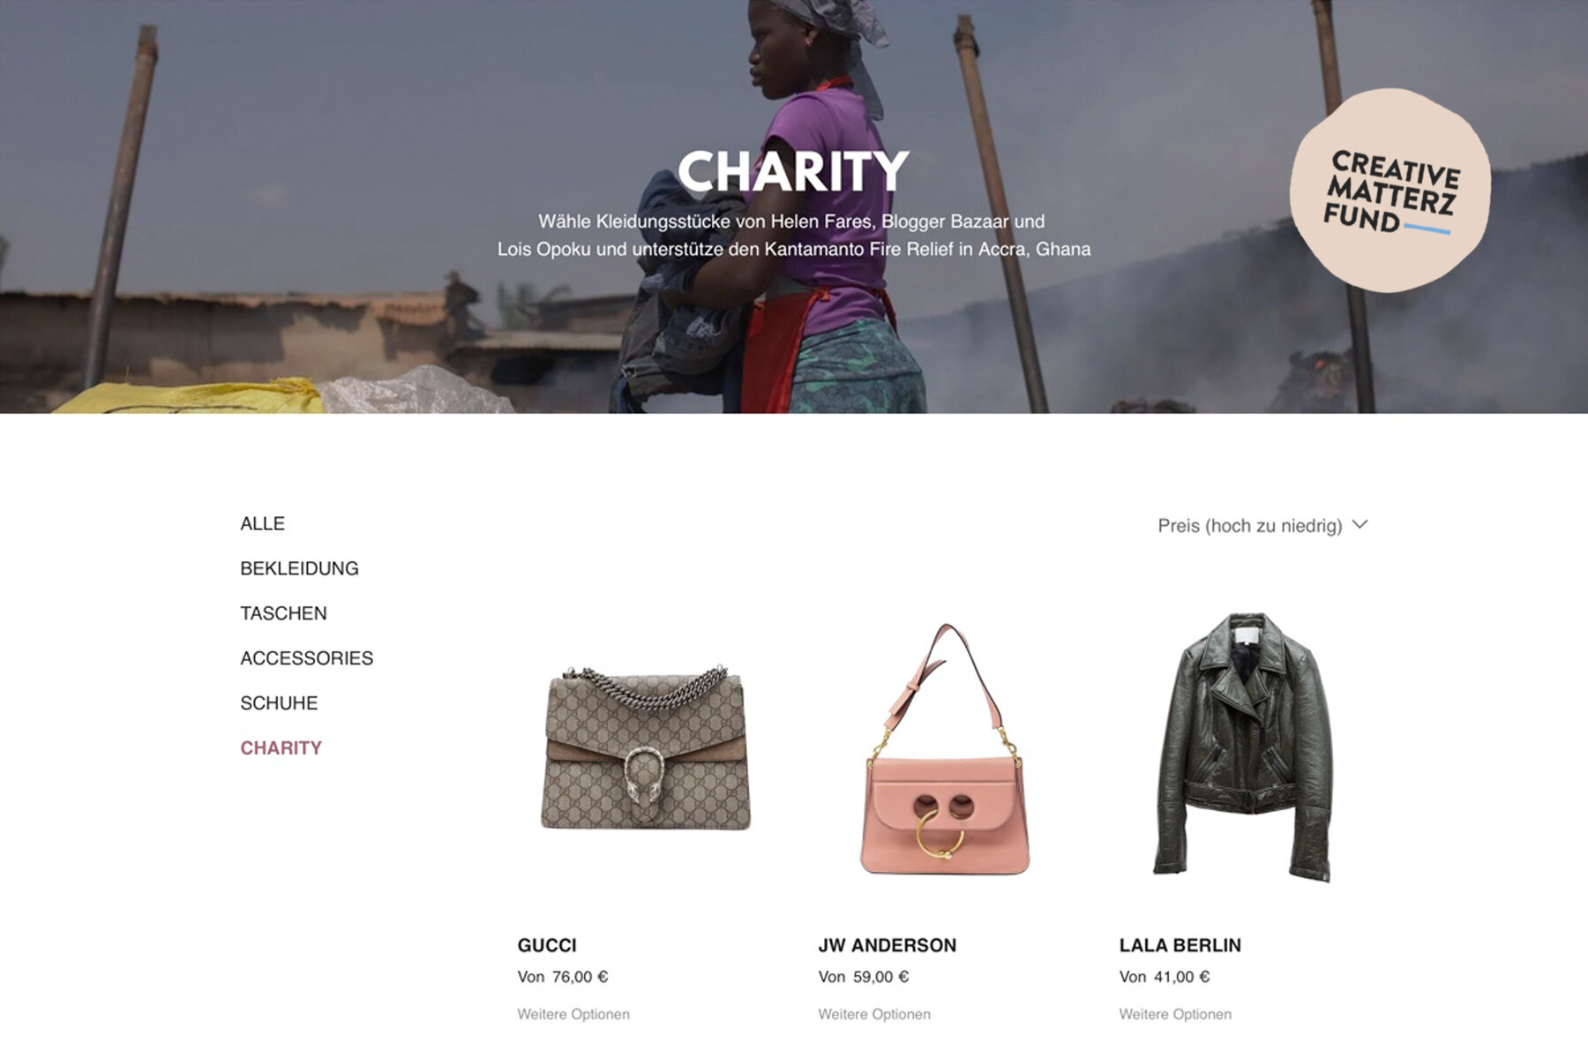

[RENTING FOR A GOOD CAUSE | Creative Matterz Fund](https://www.sustainablefashionmatterz.com/sustainable-fashion-blog/rentingforagoodcause-24ebh-ygst8)

August 2, 2021

With this charity rental campaign we aim to raise awareness of the place most people don’t think about when purchasing a new (fast fashion) item. It will educate about Kantamanto, one of the places where our clothes end up when we think we do something good by donating them to a charity collection bin. By opening the wardrobes of influencers Blogger Bazaar, Helen Fares & Lois Opoku to the public, renting, a circular way of consuming fashion is made attractive. Renters can choose between 3, 6 and 12 Day rental and get it delivered emission and packaging free straight to their door. With all rental proceeds going to the Fire Relief Fund we’re able to get them closer to their go-fund-me goal and have people looking good while doing good.

[Read More](https://www.sustainablefashionmatterz.com/sustainable-fashion-blog/rentingforagoodcause-24ebh-ygst8)

In [Brands](https://www.sustainablefashionmatterz.com/sustainable-fashion-blog/category/Brands)Tags [Creative Matterz Fund](https://www.sustainablefashionmatterz.com/sustainable-fashion-blog/tag/Creative+Matterz+Fund), [Creative Matterz Fund Round N°1](https://www.sustainablefashionmatterz.com/sustainable-fashion-blog/tag/Creative+Matterz+Fund+Round+N%C2%B01)

0 Likes[Comment](https://www.sustainablefashionmatterz.com/sustainable-fashion-blog/rentingforagoodcause-24ebh-ygst8#comments-60d455fb64781f71252ae325)

Share

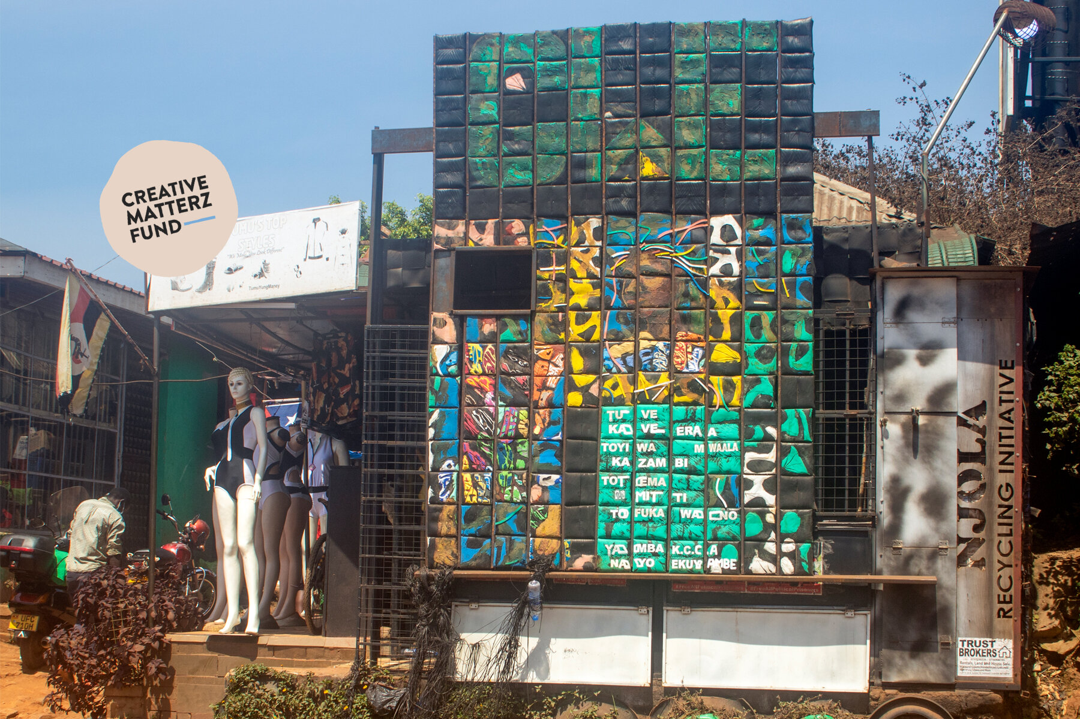

[XCESS Street Art | Creative Matterz Fund](https://www.sustainablefashionmatterz.com/sustainable-fashion-blog/xcess-street-art-creative-matterz-fund)

August 2, 2021

Xcess is a composition of 200 bags made out of plastic waste. Transforming polythene, car tyres and flip flops into bags. The materials used do not decay and accumulate hence causing hazards to the Environment. We are targeting 'Excess' garbage with in Kampala communities. We are creating a solution where negative excess becomes positive through productivity.

[Read More](https://www.sustainablefashionmatterz.com/sustainable-fashion-blog/xcess-street-art-creative-matterz-fund)

In [Activism & Politics](https://www.sustainablefashionmatterz.com/sustainable-fashion-blog/category/Activism+%26+Politics)Tags [Creative Matterz Fund](https://www.sustainablefashionmatterz.com/sustainable-fashion-blog/tag/Creative+Matterz+Fund), [Creative Matterz Fund Round N°1](https://www.sustainablefashionmatterz.com/sustainable-fashion-blog/tag/Creative+Matterz+Fund+Round+N%C2%B01)

0 Likes[3 Comments](https://www.sustainablefashionmatterz.com/sustainable-fashion-blog/xcess-street-art-creative-matterz-fund#comments-60d45b19b91d6c310fdf5d6c)

Share

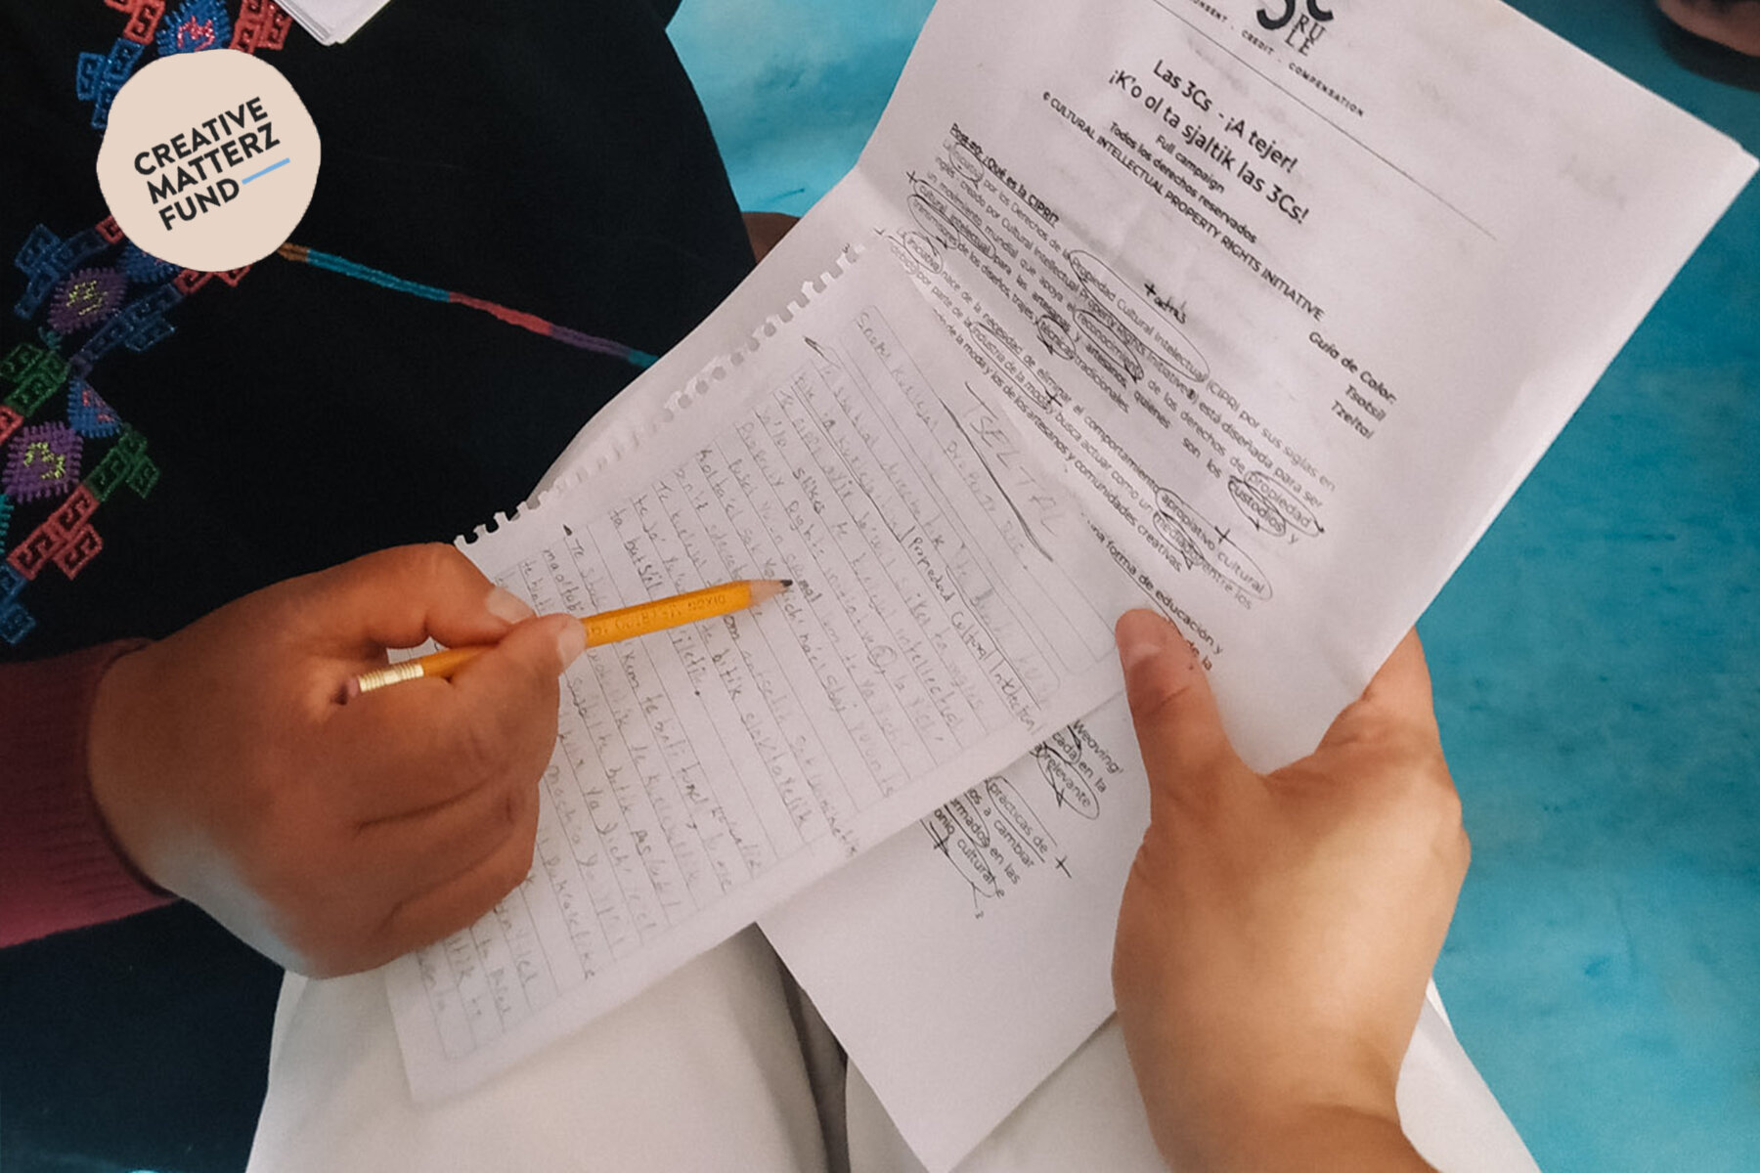

[The 3Cs - Get Weaving! Translation | Creative Matterz Fund](https://www.sustainablefashionmatterz.com/sustainable-fashion-blog/the-3cs-get-weaving-translation-creative-matterz-fund)

August 2, 2021

To help the fashion industry treat Indigenous and craft communities with fairness and equity, the [Cultural Intellectual Property Rights Initiative](https://www.culturalintellectualproperty.com/)® developed the 3Cs' Rule: Consent. Credit. Compensation ©. The 3Cs - Get Weaving! Campaign is an informative online, social media campaign focused on the 3Cs' Rule and the relevant terminology associated with it.

[Read More](https://www.sustainablefashionmatterz.com/sustainable-fashion-blog/the-3cs-get-weaving-translation-creative-matterz-fund)

In [Activism & Politics](https://www.sustainablefashionmatterz.com/sustainable-fashion-blog/category/Activism+%26+Politics)Tags [Creative Matterz Fund](https://www.sustainablefashionmatterz.com/sustainable-fashion-blog/tag/Creative+Matterz+Fund), [Creative Matterz Fund Round N°1](https://www.sustainablefashionmatterz.com/sustainable-fashion-blog/tag/Creative+Matterz+Fund+Round+N%C2%B01)

0 Likes[1 Comment](https://www.sustainablefashionmatterz.com/sustainable-fashion-blog/the-3cs-get-weaving-translation-creative-matterz-fund#comments-60d4587744a38359d2fce830)

Share

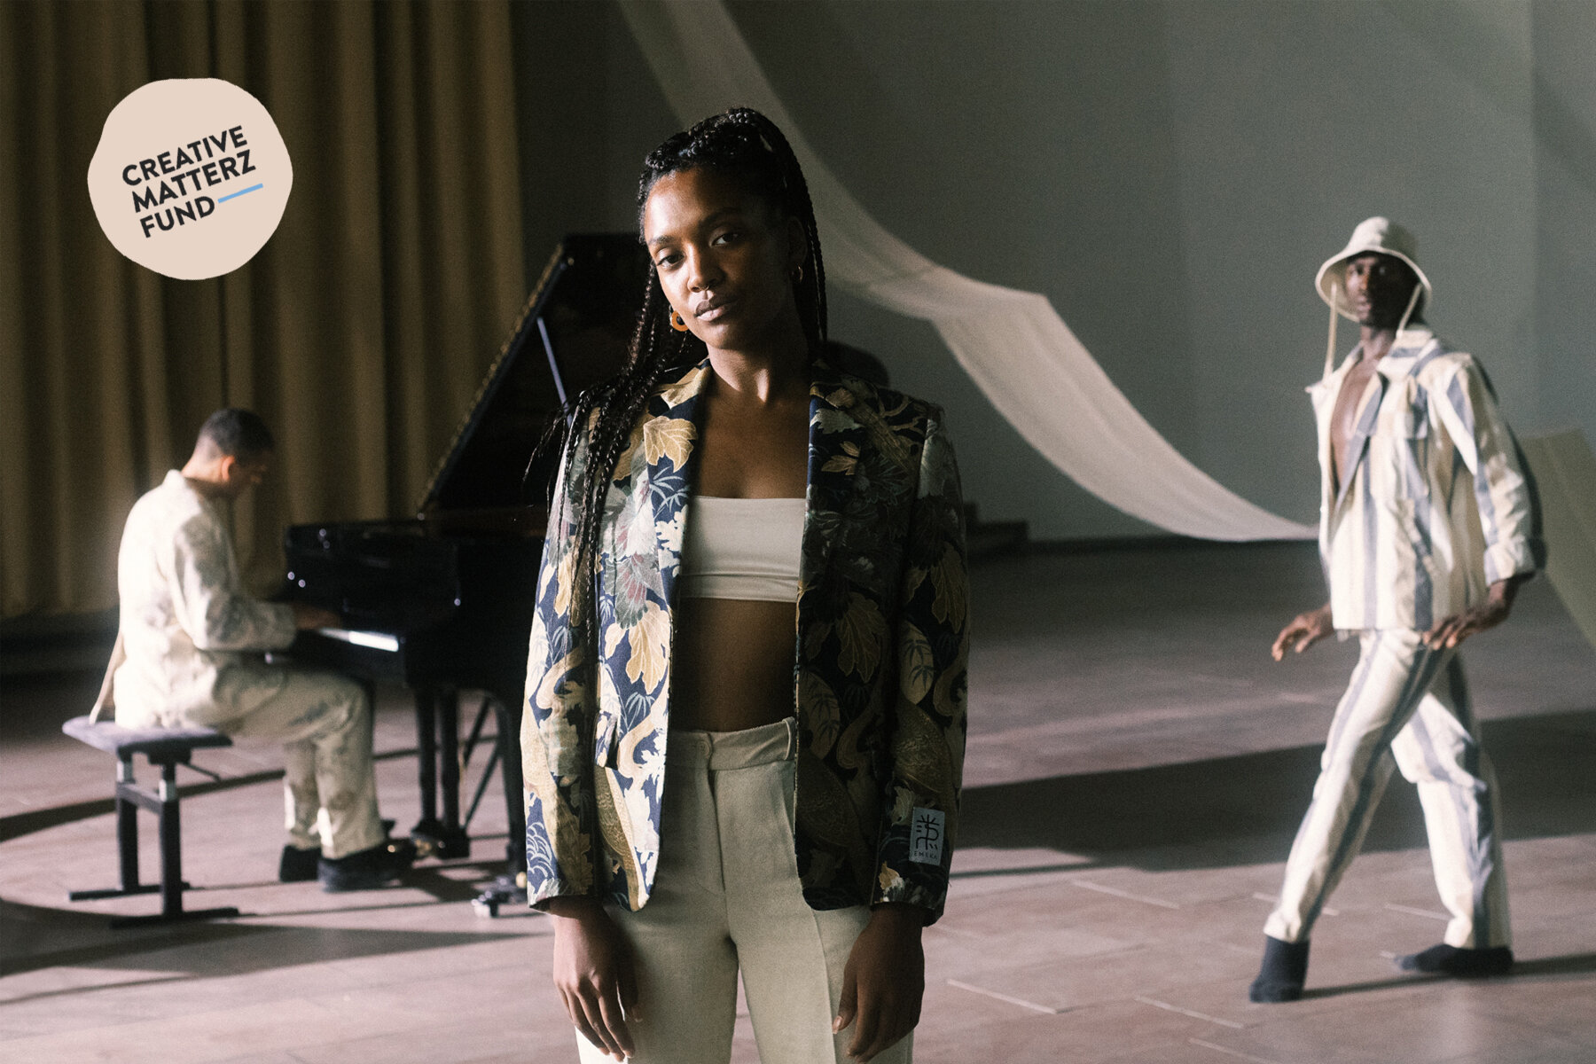

©Milena Wegner

[CYCLES Film | Creative Matterz Fund](https://www.sustainablefashionmatterz.com/sustainable-fashion-blog/cycles-film-creative-matterz-fund)

August 2, 2021

CYCLES, a visual journey, exploring the topic of Circularity through culture, dance, music & fashion. We know we need to move towards a more holistic and circular understanding of the world in order to live within the means of our planet. But what does circularity really mean? How can we embrace it through fashion, through music, through dance, through culture? With this film we want to explore the idea of circular culture. By uniting different fields of artistry under the topic of circularity, we created a visual essay that can help us understand our circular nature. The film is planned to be released mid-end August.

[Read More](https://www.sustainablefashionmatterz.com/sustainable-fashion-blog/cycles-film-creative-matterz-fund)

In [Brands](https://www.sustainablefashionmatterz.com/sustainable-fashion-blog/category/Brands)Tags [Creative Matterz Fund](https://www.sustainablefashionmatterz.com/sustainable-fashion-blog/tag/Creative+Matterz+Fund), [Creative Matterz Fund Round N°1](https://www.sustainablefashionmatterz.com/sustainable-fashion-blog/tag/Creative+Matterz+Fund+Round+N%C2%B01)

0 Likes[1 Comment](https://www.sustainablefashionmatterz.com/sustainable-fashion-blog/cycles-film-creative-matterz-fund#comments-60d459b087b40a040e4510da)

Share



[PILLAR 5 Sustainable Fashion Platform | Creative Matterz Fund](https://www.sustainablefashionmatterz.com/sustainable-fashion-blog/pillar-5-sustainable-fashion-platform-creative-matterz-fund)

August 2, 2021

Pillar 5 is a multi-layered business model, centering around two main pillars: our curated, ethical marketplace and the visual story telling of designers and makers. As the name already reveals leans the project on five layers in total, which we will mention in the following:

[Read More](https://www.sustainablefashionmatterz.com/sustainable-fashion-blog/pillar-5-sustainable-fashion-platform-creative-matterz-fund)

In [Activism & Politics](https://www.sustainablefashionmatterz.com/sustainable-fashion-blog/category/Activism+%26+Politics), [Brands](https://www.sustainablefashionmatterz.com/sustainable-fashion-blog/category/Brands)Tags [Creative Matterz Fund](https://www.sustainablefashionmatterz.com/sustainable-fashion-blog/tag/Creative+Matterz+Fund), [Creative Matterz Fund Round N°1](https://www.sustainablefashionmatterz.com/sustainable-fashion-blog/tag/Creative+Matterz+Fund+Round+N%C2%B01)

0 Likes[1 Comment](https://www.sustainablefashionmatterz.com/sustainable-fashion-blog/pillar-5-sustainable-fashion-platform-creative-matterz-fund#comments-60d44f839747b215340142fa)

Share

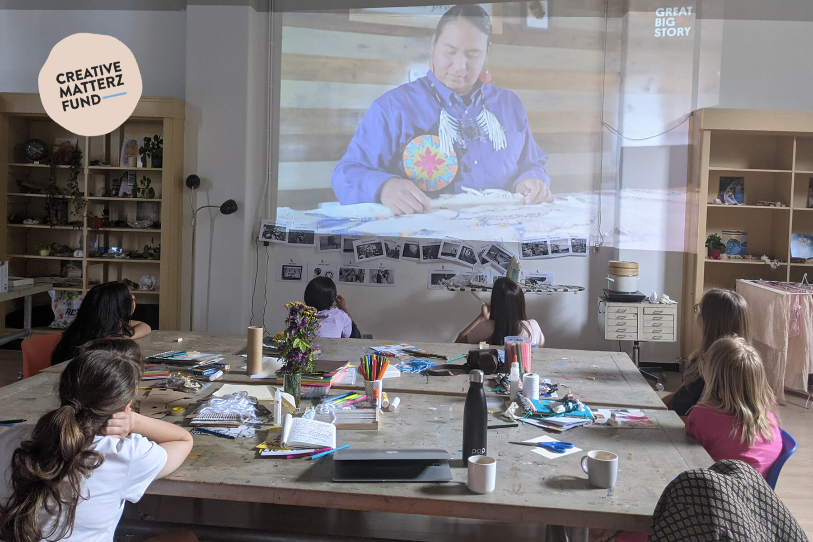

Photo: @adoretextilearts

[TEXTILE ARTS SUMMER CAMP | Creative Matterz Fund](https://www.sustainablefashionmatterz.com/sustainable-fashion-blog/textile-arts-summer-camp-creative-matterz-fund)

August 2, 2021

We have created a week long day summer camp and workshops geared towards kids ages 8-12. Using different themes on the environmental and social implications of the fast fashion industry, we want to educate kids about where their clothing comes from, who makes it and in what conditions, and what happens to it at the end of the life cycle. We have partnered with a Canadian non-profit organization called Fashion Takes Action to use some of their educational materials, and will also include textile arts projects so that kids can practice some techniques, get creative, and develop an appreciation for the work that goes into what we wear.

[Read More](https://www.sustainablefashionmatterz.com/sustainable-fashion-blog/textile-arts-summer-camp-creative-matterz-fund)

In [Events](https://www.sustainablefashionmatterz.com/sustainable-fashion-blog/category/Events)Tags [Creative Matterz Fund](https://www.sustainablefashionmatterz.com/sustainable-fashion-blog/tag/Creative+Matterz+Fund), [Creative Matterz Fund Round N°1](https://www.sustainablefashionmatterz.com/sustainable-fashion-blog/tag/Creative+Matterz+Fund+Round+N%C2%B01)

0 Likes[Comment](https://www.sustainablefashionmatterz.com/sustainable-fashion-blog/textile-arts-summer-camp-creative-matterz-fund#comments-60d45722b91d6c310fdf2926)

Share

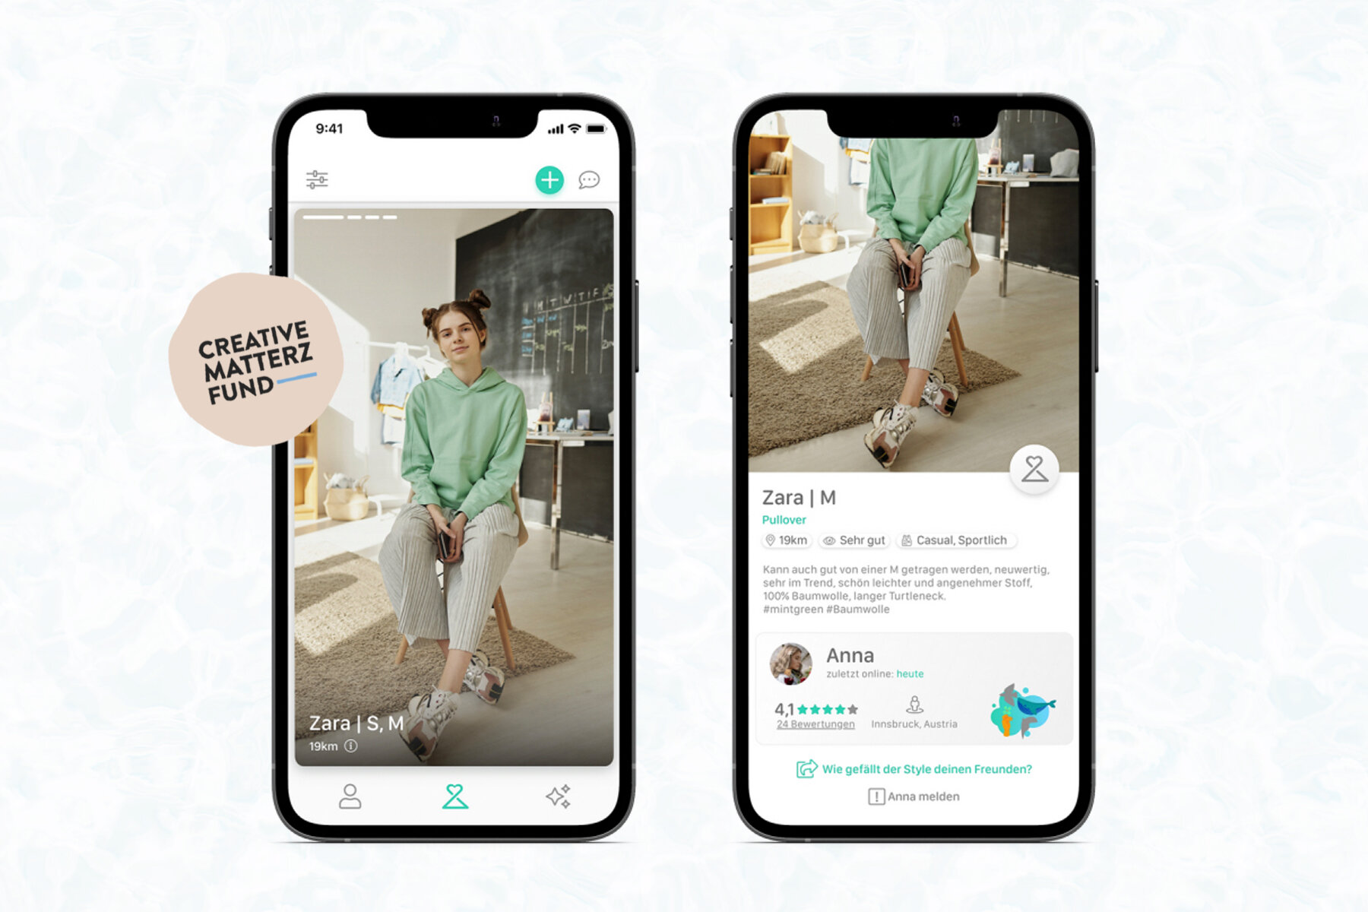

[UPTRADED Swipe and Swap Your Clothes! | Creative Matterz Fund](https://www.sustainablefashionmatterz.com/sustainable-fashion-blog/uptraded-swipe-and-swap-your-clothes-creative-matterz-fund)

August 2, 2021

“Our vision is to make fashion sustainable together, by creating the world’s biggest collaborative closet.” - [@uptraded](https://www.instagram.com/uptraded/)  
Uptraded, founded by Anna and Bruno, have worked on the development of their tinder style Clothes Swapping app and motivated…

[Read More](https://www.sustainablefashionmatterz.com/sustainable-fashion-blog/uptraded-swipe-and-swap-your-clothes-creative-matterz-fund)

In [Brands](https://www.sustainablefashionmatterz.com/sustainable-fashion-blog/category/Brands)Tags [Creative Matterz Fund](https://www.sustainablefashionmatterz.com/sustainable-fashion-blog/tag/Creative+Matterz+Fund), [Creative Matterz Fund Round N°1](https://www.sustainablefashionmatterz.com/sustainable-fashion-blog/tag/Creative+Matterz+Fund+Round+N%C2%B01)

0 Likes[Comment](https://www.sustainablefashionmatterz.com/sustainable-fashion-blog/uptraded-swipe-and-swap-your-clothes-creative-matterz-fund#comments-60d45496786a2c0d379d30df)

Share

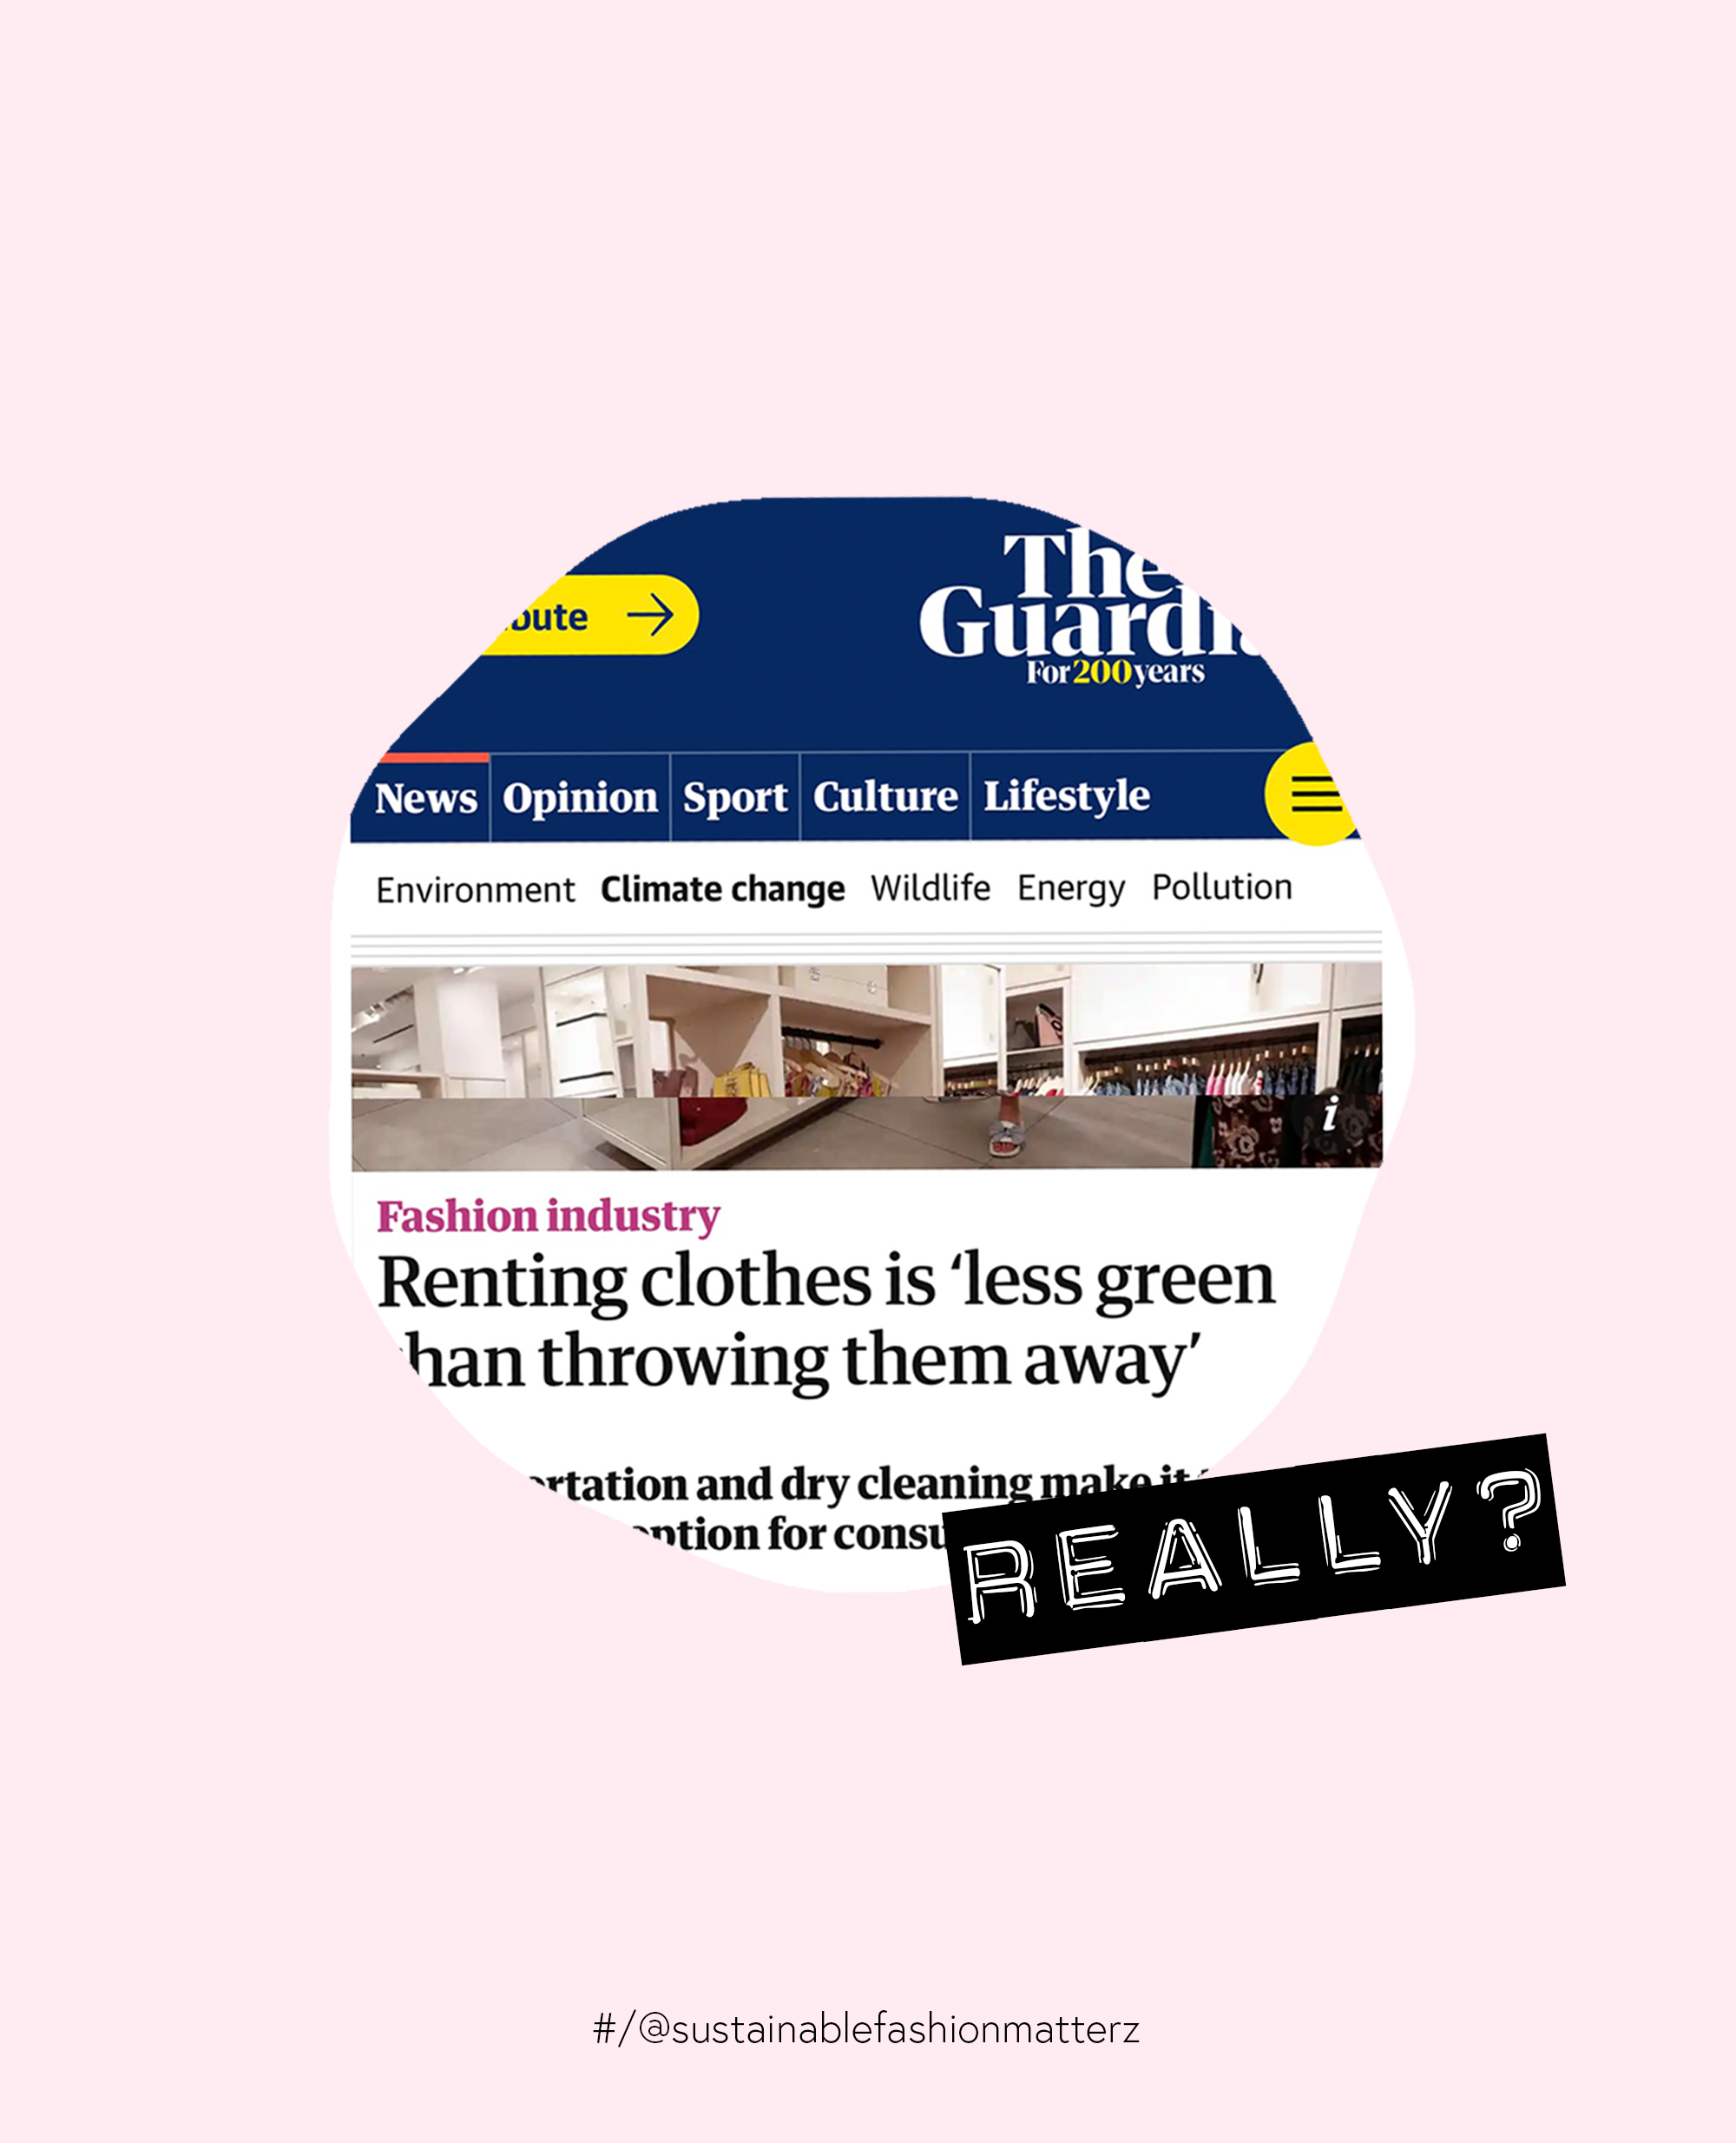

[Dear Guardian, Renting Clothes is NOT Less Green Than Throwing Them Away If You Do It Right](https://www.sustainablefashionmatterz.com/sustainable-fashion-blog/dear-guardian-renting-clothes-is-not-less-green-than-throwing-them-away-if-you-do-it-right)

July 9, 2021

The Guardian recently published an article stating that “[Renting clothes is less green than throwing them away](https://www.theguardian.com/fashion/2021/jul/06/renting-clothes-is-less-green-than-throwing-them-away)”. The article is based on a [study by IOP science](https://iopscience.iop.org/article/10.1088/1748-9326/abfac3/pdf) which came to multiple conclusions, one of which ranked Rental as the most GWP (Global Warming Potential)*in comparison to* … READ MORE

[Read More](https://www.sustainablefashionmatterz.com/sustainable-fashion-blog/dear-guardian-renting-clothes-is-not-less-green-than-throwing-them-away-if-you-do-it-right)

In [Greenwashing](https://www.sustainablefashionmatterz.com/sustainable-fashion-blog/category/Greenwashing)Tags [The Guardian](https://www.sustainablefashionmatterz.com/sustainable-fashion-blog/tag/The+Guardian), [Fake News](https://www.sustainablefashionmatterz.com/sustainable-fashion-blog/tag/Fake+News), [Clothing Rental Service](https://www.sustainablefashionmatterz.com/sustainable-fashion-blog/tag/Clothing+Rental+Service)

0 Likes[Comment](https://www.sustainablefashionmatterz.com/sustainable-fashion-blog/dear-guardian-renting-clothes-is-not-less-green-than-throwing-them-away-if-you-do-it-right#comments-60e8304fadf2c268820419d2)

Share



ADVERTISEMENT

[5 THINGS TO DO THIS SUMMER ON A DAYCATION | Biodiversity with Wildling](https://www.sustainablefashionmatterz.com/sustainable-fashion-blog/5-things-to-do-this-summer-when-traveling-locally-with-wildling)

June 29, 2021

What is your next local destination? It’s summer in the city, and the perfect time to go out and get in touch with nature. So I called up my friend [Yolanda](https://www.sustainablefashionmatterz.com/about-sustainable-fashion-matterz), who is also part of the Creative Matterz Fund team, and asked her to join me for a day trip with [Wildling minimal shoes](https://bit.ly/2W9Ie1I).

[Read More](https://www.sustainablefashionmatterz.com/sustainable-fashion-blog/5-things-to-do-this-summer-when-traveling-locally-with-wildling)

In [Brands](https://www.sustainablefashionmatterz.com/sustainable-fashion-blog/category/Brands)Tags [Wildling](https://www.sustainablefashionmatterz.com/sustainable-fashion-blog/tag/Wildling), [Biodiversity](https://www.sustainablefashionmatterz.com/sustainable-fashion-blog/tag/Biodiversity), [Daycation](https://www.sustainablefashionmatterz.com/sustainable-fashion-blog/tag/Daycation), [Travel Local](https://www.sustainablefashionmatterz.com/sustainable-fashion-blog/tag/Travel+Local), [Minimal Shoes](https://www.sustainablefashionmatterz.com/sustainable-fashion-blog/tag/Minimal+Shoes), [Barefoot Shoes](https://www.sustainablefashionmatterz.com/sustainable-fashion-blog/tag/Barefoot+Shoes), [Shoes](https://www.sustainablefashionmatterz.com/sustainable-fashion-blog/tag/Shoes)

0 Likes[Comment](https://www.sustainablefashionmatterz.com/sustainable-fashion-blog/5-things-to-do-this-summer-when-traveling-locally-with-wildling#comments-60d20bfd94cde9726e9d38d9)

Share

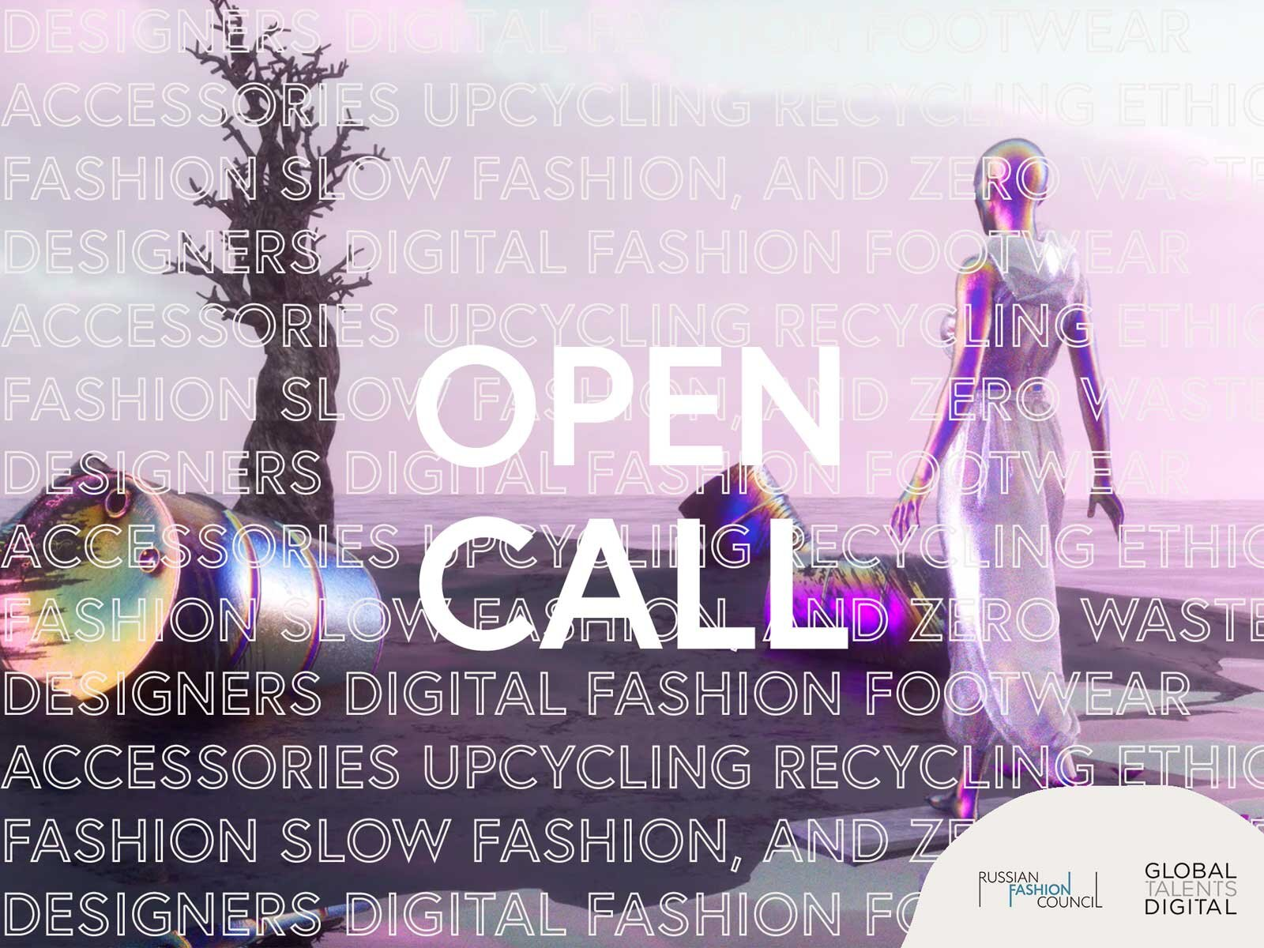

Image: Alexander Pevchev

[OPEN CALL: Designers of Virtual and Physical Fashion](https://www.sustainablefashionmatterz.com/sustainable-fashion-blog/2021/6/12/open-call-designers-of-virtual-and-physical-fashion)

June 13, 2021

The Russian Fashion Council invites designers from across the globe to apply for the international hybrid fashion event - Global Talents Digital.

[Read More](https://www.sustainablefashionmatterz.com/sustainable-fashion-blog/2021/6/12/open-call-designers-of-virtual-and-physical-fashion)

In [Events](https://www.sustainablefashionmatterz.com/sustainable-fashion-blog/category/Events)Tags [Open Call](https://www.sustainablefashionmatterz.com/sustainable-fashion-blog/tag/Open+Call), [Russion Fashion Council](https://www.sustainablefashionmatterz.com/sustainable-fashion-blog/tag/Russion+Fashion+Council), [Global Talents Digital](https://www.sustainablefashionmatterz.com/sustainable-fashion-blog/tag/Global+Talents+Digital)

0 Likes[1 Comment](https://www.sustainablefashionmatterz.com/sustainable-fashion-blog/2021/6/12/open-call-designers-of-virtual-and-physical-fashion#comments-60c49975f5c2833ef86fc1e0)

Share

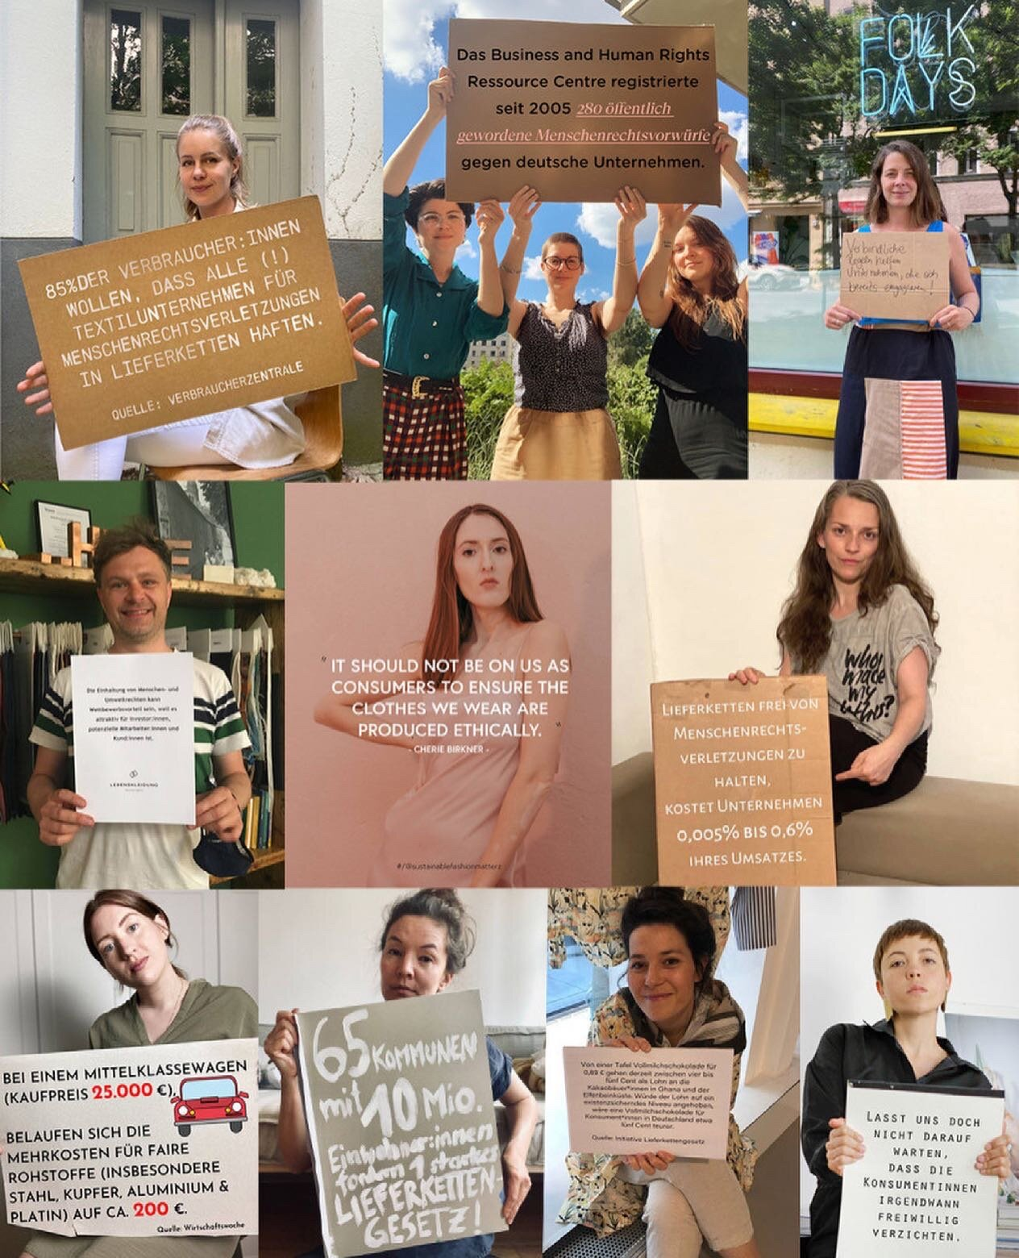

[BREAKING NEWZ: Germany has a Supply Chain Law!](https://www.sustainablefashionmatterz.com/sustainable-fashion-blog/2021/6/11/breaking-newz-germany-has-a-supply-chain-law)

June 11, 2021

Germany passes the Supply Chain Law as a step towards improving the working conditions of those involved in the production of products from German companies. It could be stronger…

[Read More](https://www.sustainablefashionmatterz.com/sustainable-fashion-blog/2021/6/11/breaking-newz-germany-has-a-supply-chain-law)

In [Activism & Politics](https://www.sustainablefashionmatterz.com/sustainable-fashion-blog/category/Activism+%26+Politics)Tags [Lieferkettengesetz](https://www.sustainablefashionmatterz.com/sustainable-fashion-blog/tag/Lieferkettengesetz), [Supply Chain Law](https://www.sustainablefashionmatterz.com/sustainable-fashion-blog/tag/Supply+Chain+Law), [Politics](https://www.sustainablefashionmatterz.com/sustainable-fashion-blog/tag/Politics)

0 Likes[Comment](https://www.sustainablefashionmatterz.com/sustainable-fashion-blog/2021/6/11/breaking-newz-germany-has-a-supply-chain-law#comments-60c33b95ce2ea26a035afe94)

Share

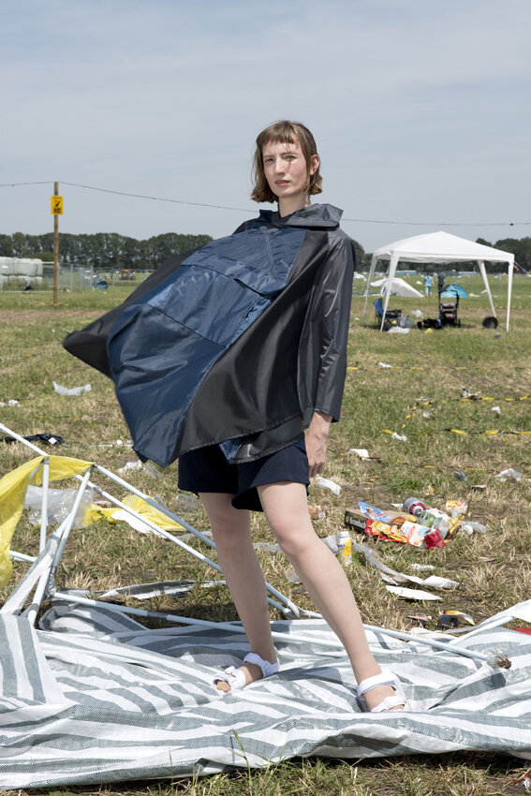

©️Manuela Gangl

[WHEN A TENT TURNS TO TRASH BUT IT'S GONNA RAIN AGAIN | Tentation Upcycling Fashion #Crowdfunding](https://www.sustainablefashionmatterz.com/sustainable-fashion-blog/when-a-tent-turns-to-trash-but-its-gonna-rain-again-tentation-upcycling-fashion-crowdfunding)

May 21, 2021

Have you ever seen what’s left over to go to waste after a festival? To be honest I haven’t. I’ve only even been to one festival in my life. So, little did I know; when the base stops bumping and we have found our ways home there is a whole landscape of trash left over… Or wait:

[Read More](https://www.sustainablefashionmatterz.com/sustainable-fashion-blog/when-a-tent-turns-to-trash-but-its-gonna-rain-again-tentation-upcycling-fashion-crowdfunding)

In [Brands](https://www.sustainablefashionmatterz.com/sustainable-fashion-blog/category/Brands)Tags [Upcycling](https://www.sustainablefashionmatterz.com/sustainable-fashion-blog/tag/Upcycling), [Tentation](https://www.sustainablefashionmatterz.com/sustainable-fashion-blog/tag/Tentation), [Katrin Reiber](https://www.sustainablefashionmatterz.com/sustainable-fashion-blog/tag/Katrin+Reiber), [Rainwear](https://www.sustainablefashionmatterz.com/sustainable-fashion-blog/tag/Rainwear), [Outdoor Clothing](https://www.sustainablefashionmatterz.com/sustainable-fashion-blog/tag/Outdoor+Clothing)

0 Likes[Comment](https://www.sustainablefashionmatterz.com/sustainable-fashion-blog/when-a-tent-turns-to-trash-but-its-gonna-rain-again-tentation-upcycling-fashion-crowdfunding#comments-60a68f440a15fb41b5bb0fec)

Share



[OPEN CALL: ART ON BROKEN PIECES | Calling all Upcycling Enthusiasts](https://www.sustainablefashionmatterz.com/sustainable-fashion-blog/2021/5/18/open-call-art-on-broken-pieces-calling-all-upcycling-enthusiasts)

May 18, 2021

Are you a creative mind interested in upcycling projects? Then DAWN Denim is looking for you!

[Read More](https://www.sustainablefashionmatterz.com/sustainable-fashion-blog/2021/5/18/open-call-art-on-broken-pieces-calling-all-upcycling-enthusiasts)

In [Brands](https://www.sustainablefashionmatterz.com/sustainable-fashion-blog/category/Brands), [Events](https://www.sustainablefashionmatterz.com/sustainable-fashion-blog/category/Events)Tags [DAWN Denim](https://www.sustainablefashionmatterz.com/sustainable-fashion-blog/tag/DAWN+Denim), [Open Call](https://www.sustainablefashionmatterz.com/sustainable-fashion-blog/tag/Open+Call), [Art](https://www.sustainablefashionmatterz.com/sustainable-fashion-blog/tag/Art), [Upcycling](https://www.sustainablefashionmatterz.com/sustainable-fashion-blog/tag/Upcycling)

0 Likes[Comment](https://www.sustainablefashionmatterz.com/sustainable-fashion-blog/2021/5/18/open-call-art-on-broken-pieces-calling-all-upcycling-enthusiasts#comments-60a3b57ebcf9404bd63a34f0)

Share



[LIMITED EDITION FUNDRAISER | Growing by Attitude](https://www.sustainablefashionmatterz.com/sustainable-fashion-blog/limited-edition-fundraiser-growing-by-attitude)

May 4, 2021

Every month at [**Heart Directors Club**](https://heartdirectorsclub.org/) a group of selected designers and artists sell limited artworks for a good purpose. For the current May Edition they have chosen to contributed to the Creative Fashion Matterz Fund 🤍.

[Read More](https://www.sustainablefashionmatterz.com/sustainable-fashion-blog/limited-edition-fundraiser-growing-by-attitude)

In [Brands](https://www.sustainablefashionmatterz.com/sustainable-fashion-blog/category/Brands)Tags [Heart Directors Club](https://www.sustainablefashionmatterz.com/sustainable-fashion-blog/tag/Heart+Directors+Club), [Fundraiser](https://www.sustainablefashionmatterz.com/sustainable-fashion-blog/tag/Fundraiser), [Creative Matterz Fund](https://www.sustainablefashionmatterz.com/sustainable-fashion-blog/tag/Creative+Matterz+Fund), [Limited Edition](https://www.sustainablefashionmatterz.com/sustainable-fashion-blog/tag/Limited+Edition), [T-shirt](https://www.sustainablefashionmatterz.com/sustainable-fashion-blog/tag/T-shirt), [Art](https://www.sustainablefashionmatterz.com/sustainable-fashion-blog/tag/Art)

0 Likes[Comment](https://www.sustainablefashionmatterz.com/sustainable-fashion-blog/limited-edition-fundraiser-growing-by-attitude#comments-6091af84e60f74349fe355f6)

Share

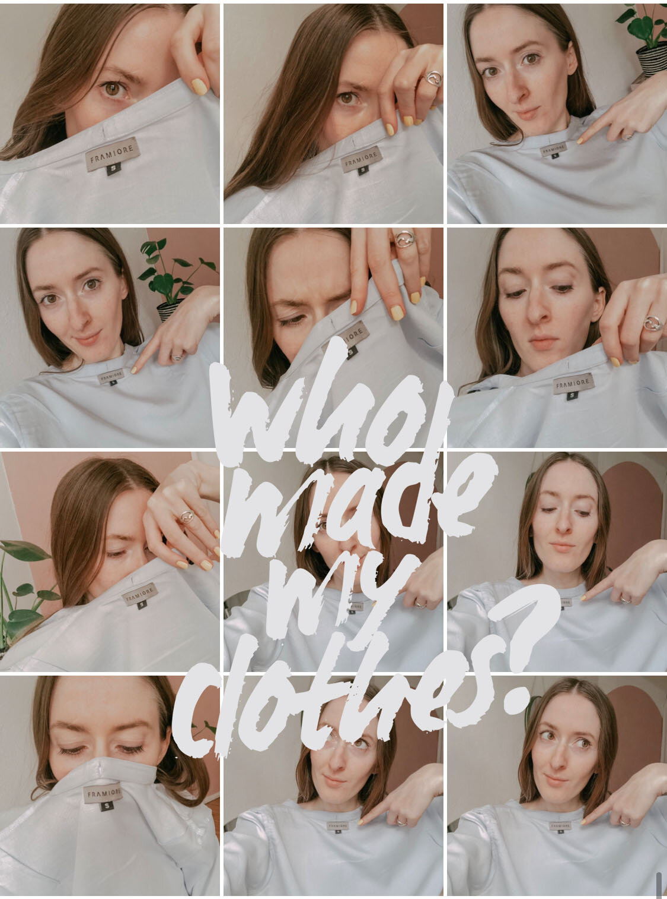

[5 WAYS TO PARTICIPATE IN FASHION REVOLUTION | 2021 Edition](https://www.sustainablefashionmatterz.com/sustainable-fashion-blog/5-ways-to-participate-in-fashion-revolution-2021-edition)

April 23, 2021

What is Fashion Revolution? Why You Should Be Part Of It(!) and 5 Ways to Participate in 2021. Hashtags. Profile Pictures. Face Filters. E-mail Templates. #UseYourWindow- #WhoMadeMyClothes.

[Read More](https://www.sustainablefashionmatterz.com/sustainable-fashion-blog/5-ways-to-participate-in-fashion-revolution-2021-edition)

In [Activism & Politics](https://www.sustainablefashionmatterz.com/sustainable-fashion-blog/category/Activism+%26+Politics), [Events](https://www.sustainablefashionmatterz.com/sustainable-fashion-blog/category/Events)Tags [Fashion Revolution](https://www.sustainablefashionmatterz.com/sustainable-fashion-blog/tag/Fashion+Revolution), [Fashion Revolution 2021](https://www.sustainablefashionmatterz.com/sustainable-fashion-blog/tag/Fashion+Revolution+2021), [#WhoMadeMyClothes](https://www.sustainablefashionmatterz.com/sustainable-fashion-blog/tag/%23WhoMadeMyClothes), [Face Filter](https://www.sustainablefashionmatterz.com/sustainable-fashion-blog/tag/Face+Filter), [#UseYourWindow](https://www.sustainablefashionmatterz.com/sustainable-fashion-blog/tag/%23UseYourWindow), [Social Media](https://www.sustainablefashionmatterz.com/sustainable-fashion-blog/tag/Social+Media)

0 Likes[2 Comments](https://www.sustainablefashionmatterz.com/sustainable-fashion-blog/5-ways-to-participate-in-fashion-revolution-2021-edition#comments-6081d5f361d9ee29ffd86861)

Share

[Older →](https://www.sustainablefashionmatterz.com/sustainable-fashion-blog?offset=1619132622927)





[**CHERIE BIRKNER**](https://www.sustainablefashionmatterz.com/about-sustainable-fashion-matterz) is a multidisciplinary creative, focusing her energy towards sustainability focused projects, brands and people. Since she quit fast fashion in 2016 she has created Sustainable Fashion Matterz as a space to give easy access to solutions in the fashion industry. Read more about her [here](https://www.sustainablefashionmatterz.com/cherie-birkner).

[**GUEST CONTRIBUTORS**](https://www.sustainablefashionmatterz.com/contributors)

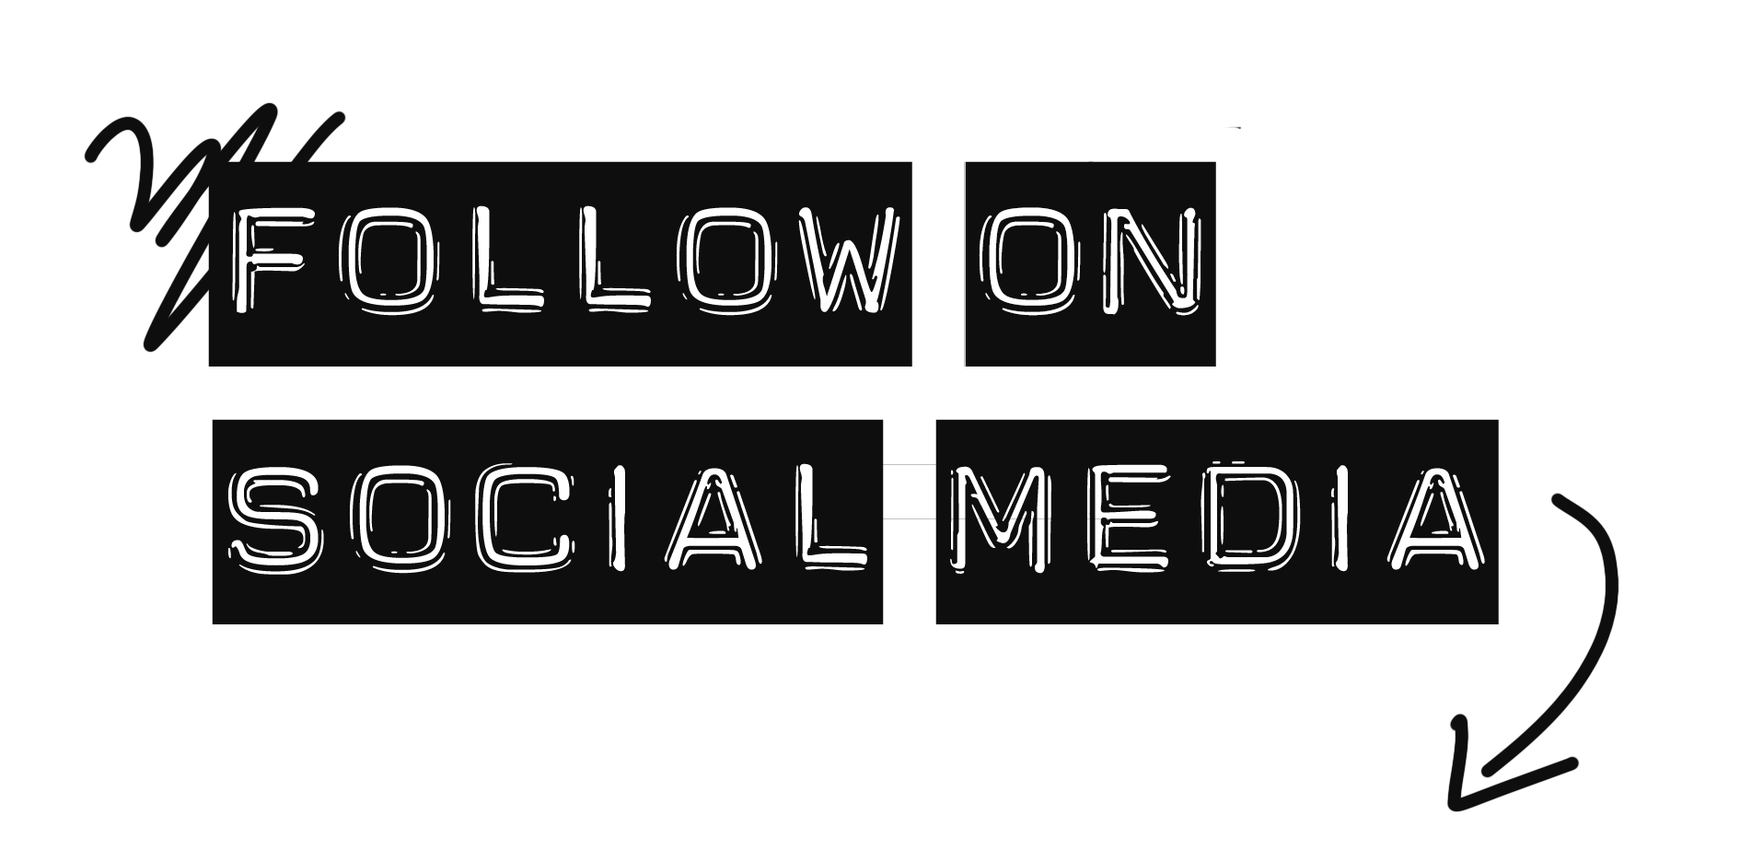

Category

[[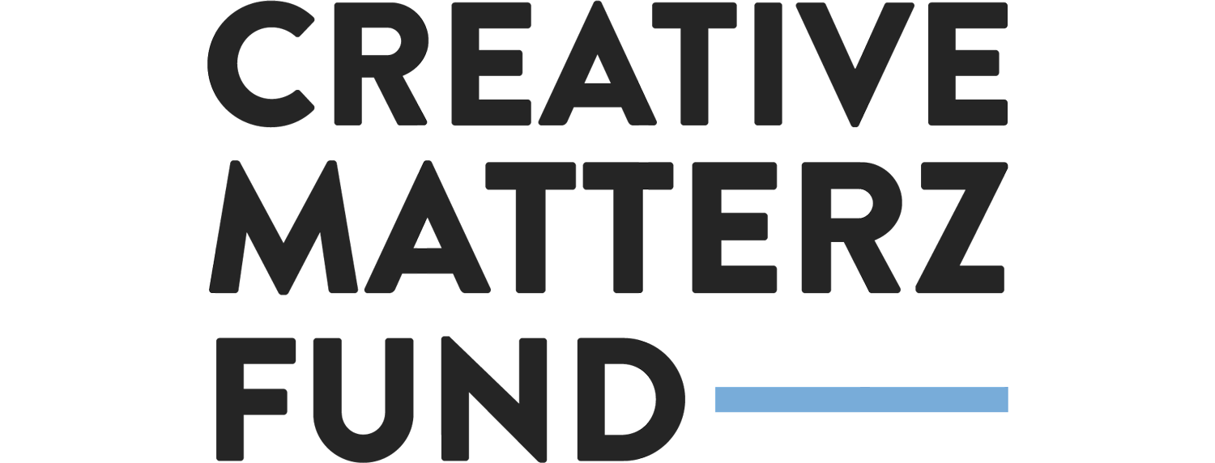](https://www.sustainablefashionmatterz.com/creative-matterz-fund)](https://www.sustainablefashionmatterz.com/creative-matterz-fund)

FEATURED

[[](https://www.sustainablefashionmatterz.com/sustainable-fashion-blog/2022/5/11/why-i-dont-know-if-i-will-continue-sustainable-fashion-matterz)](https://www.sustainablefashionmatterz.com/sustainable-fashion-blog/2022/5/11/why-i-dont-know-if-i-will-continue-sustainable-fashion-matterz)

[Why I Don't Know if I Will Continue Sustainable Fashion Matterz](https://www.sustainablefashionmatterz.com/sustainable-fashion-blog/2022/5/11/why-i-dont-know-if-i-will-continue-sustainable-fashion-matterz)

[[](https://www.sustainablefashionmatterz.com/sustainable-fashion-blog/2022/5/3/ukrainian-upcycling-designers-in-berlin)](https://www.sustainablefashionmatterz.com/sustainable-fashion-blog/2022/5/3/ukrainian-upcycling-designers-in-berlin)

[Ukrainian Upcycling Designers in Berlin](https://www.sustainablefashionmatterz.com/sustainable-fashion-blog/2022/5/3/ukrainian-upcycling-designers-in-berlin)

[[](https://www.sustainablefashionmatterz.com/sustainable-fashion-blog/4-sustainability-claims-that-brands-need-to-stop-making-my-reaction)](https://www.sustainablefashionmatterz.com/sustainable-fashion-blog/4-sustainability-claims-that-brands-need-to-stop-making-my-reaction)

[4 SUSTAINABILITY CLAIMS THAT BRANDS NEED TO STOP MAKING | My Reaction](https://www.sustainablefashionmatterz.com/sustainable-fashion-blog/4-sustainability-claims-that-brands-need-to-stop-making-my-reaction)

[[](https://www.sustainablefashionmatterz.com/sustainable-fashion-blog/what-the-fact-did-i-spread-fake-news)](https://www.sustainablefashionmatterz.com/sustainable-fashion-blog/what-the-fact-did-i-spread-fake-news)

[WHAT THE FACT! | Did I spread fake news?](https://www.sustainablefashionmatterz.com/sustainable-fashion-blog/what-the-fact-did-i-spread-fake-news)

[[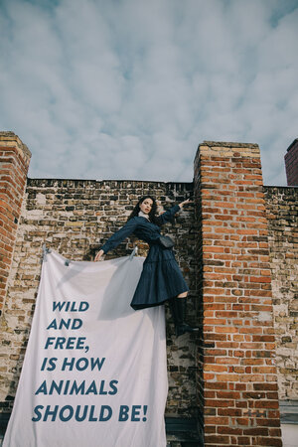](https://www.sustainablefashionmatterz.com/sustainable-fashion-blog/wild-free-animals-vegan-fashion-editorial)](https://www.sustainablefashionmatterz.com/sustainable-fashion-blog/wild-free-animals-vegan-fashion-editorial)

[WILD AND FREE, AS ANIMALS SHOULD BE | Vegan Fashion Editorial](https://www.sustainablefashionmatterz.com/sustainable-fashion-blog/wild-free-animals-vegan-fashion-editorial)

[[](https://www.sustainablefashionmatterz.com/sustainable-fashion-blog/2020/10/30/i-see-fashion-as-an-art-space-editorial-interview-with-karina-papp-found-on-the-street)](https://www.sustainablefashionmatterz.com/sustainable-fashion-blog/2020/10/30/i-see-fashion-as-an-art-space-editorial-interview-with-karina-papp-found-on-the-street)

[I SEE FASHION AS AN ART SPACE | Editorial Interview with Karina Papp - @found\_on\_the\_street](https://www.sustainablefashionmatterz.com/sustainable-fashion-blog/2020/10/30/i-see-fashion-as-an-art-space-editorial-interview-with-karina-papp-found-on-the-street)

[[](https://www.sustainablefashionmatterz.com/sustainable-fashion-blog/3-questions-every-brand-consumer-should-reflect-on-colorwashing)](https://www.sustainablefashionmatterz.com/sustainable-fashion-blog/3-questions-every-brand-consumer-should-reflect-on-colorwashing)

[3 QUESTIONS EVERY BRAND & CONSUMER SHOULD REFLECT ON | Colorwashing Check-out](https://www.sustainablefashionmatterz.com/sustainable-fashion-blog/3-questions-every-brand-consumer-should-reflect-on-colorwashing)

[[](https://www.sustainablefashionmatterz.com/sustainable-fashion-blog/colorwashing-check-new-balance)](https://www.sustainablefashionmatterz.com/sustainable-fashion-blog/colorwashing-check-new-balance)

[COLORWASHING CHECK | New Balance](https://www.sustainablefashionmatterz.com/sustainable-fashion-blog/colorwashing-check-new-balance)

[[](https://www.sustainablefashionmatterz.com/sustainable-fashion-blog/is-it-spring-or-summer-now-fair-fashion-editorial-with-kim-gerlach-sun-and-rise)](https://www.sustainablefashionmatterz.com/sustainable-fashion-blog/is-it-spring-or-summer-now-fair-fashion-editorial-with-kim-gerlach-sun-and-rise)

[IS IT SPRING OR SUMMER NOW? | Fair Fashion Editorial with Kim Gerlach sun and rise](https://www.sustainablefashionmatterz.com/sustainable-fashion-blog/is-it-spring-or-summer-now-fair-fashion-editorial-with-kim-gerlach-sun-and-rise)

[[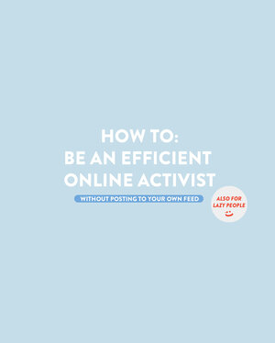](https://www.sustainablefashionmatterz.com/sustainable-fashion-blog/how-to-be-an-efficient-online-activist-also-for-lazy-people)](https://www.sustainablefashionmatterz.com/sustainable-fashion-blog/how-to-be-an-efficient-online-activist-also-for-lazy-people)

[HOW TO BE AN EFFICIENT ONLINE ACTIVIST | also for lazy people](https://www.sustainablefashionmatterz.com/sustainable-fashion-blog/how-to-be-an-efficient-online-activist-also-for-lazy-people)

[About](https://www.sustainablefashionmatterz.com/about-sustainable-fashion-matterz)  
[Press](https://www.sustainablefashionmatterz.com/press)  
[Blog](https://www.sustainablefashionmatterz.com/sustainable-fashion-blog)  
[Contact](https://www.sustainablefashionmatterz.com/contact)

Copyright 2017 - 2021  
[Impressum](https://www.sustainablefashionmatterz.com/impressundatenschutz) & [Datenschutz - DSGVO / Privacy Policy - GDPR](https://www.sustainablefashionmatterz.com/datenschutzerklrung-dsgvo-gdpr)